Why Are There So Many Unemployed People in the World?
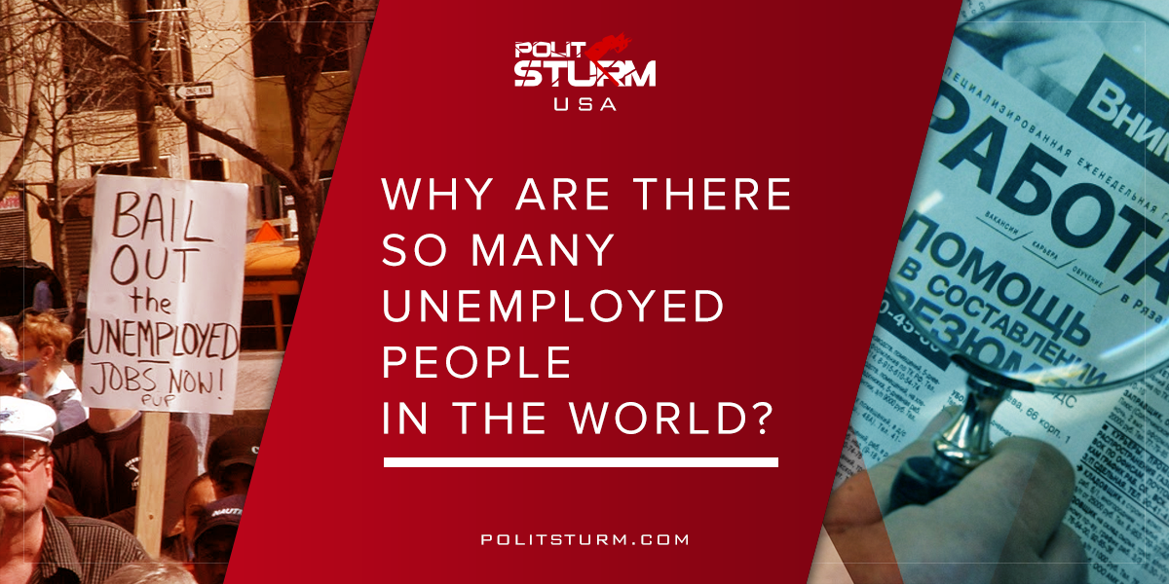

Оригинальная статья
2018-04-07
3 мин. на чтение

Many people ask this question, around which there are many myths. Well, why are there so many unemployed people? Let’s figure it out.

“You don’t have a job, because you’re lazy!”
This is impossible because of the very weak support for unemployed people in capitalist countries. A non-working person cannot pay the bills, so he will be quickly put out on the street. Therefore, the citizen will work and look for money anywhere regardless of conditions. What led to this? The capitalist system, where it is advantageous for the “employer” to keep a part of the workforce unemployed: the price of labor will be reduced, making it possible to reduce salaries. People are ready to work under any conditions in order to survive. Of course, this situation is beneficial to the ruling class.

“You don’t have a job because of your poor education”
To begin with, almost any education is good and necessary for society. The question, rather, is whether this education is necessary for the capitalists. Businessmen require the workers to have a certain amount of education in order to profit off of them. Therefore capitalist society enjoys financial success mainly from the applied disciplines. Capital is only invested in the core educational disciplines (mathematics, physics, etc.) when it expects huge profits in the future. Otherwise, this direction is not necessary for capital. It turns out that there is no work not because one has studied the “wrong” subject, but because of an unjust capitalist system.

“You have inflated demands for work”
Favorite excuse of the bourgeoisie. Ideally, the capitalist needs a worker to work for free, which actually happens every time workers are conned out of their wages. In general, the bourgeois, of course, pays a salary, but very small, and still believes that the workers should thank him for such «generosity», and for the insolent people who dare to consider that the salary is small, these are “inflated demands.” We believe that those who have inflated demands are the bourgeois. They are already robbing the workers, taking from them part of the value they created, surplus value, which is the way in which the capitalist earns a living.

“You don’t meet market and time requirements”
There is no deception here. Capital really lives by the laws of the market. Capital is always looking for new ways of making profits, and old ones that no longer make a profit are discarded, along with thousands of jobs. The bourgeois no longer needs these people, and they languish in poverty. Under socialism, technical progress will advance too and obsolete production will also be closed, but workers will not be thrown out, they will be retrained so that they can start working on. After all, society need them.

What does all of this mean?
Everything that happens is the result of an unjust capitalist system, the essence of which is the private ownership of the means of production. The owners use the labor of workers who do not have anything that they can sell, except their own labor. The owners, the capitalists, buy labor from the worker (they pay wages), but they do not pay the entire cost of the labor force, they pay only part of it, the rest of the value, surplus value, they take it in their pocket. This is their wealth. It is advantageous for the bourgeois to have an army of unemployed, because all of this beats the price of labor down. The worker is afraid of being fired and agrees to work for a meager salary. In addition, if the workers still decide to fight for their rights, for example, to strike, they can always be dismissed and replaced with new employees, or not dismissed, but temporarily used against the unemployed as strikebreakers. Under capitalism, the unemployed will always exist.

What to do?
Only with the destruction of the capitalist mode of production, through the revolutionary political struggle, are the conditions for the economic and political oppression of the working class eliminated. Only then it is possible to establish the power of the working class, the dictatorship of the proletariat. Then the means of production are socialized, the former property of the capitalists becomes the property of the entire working class, and then the labor of the worker ceases to be a commodity, this becomes a contribution to a socialist society whose purpose is to satisfy the ever growing needs of society. This is the only way to eliminate unemployment. There is no other way.

Оригинальная статья

