USA arm Ukrainian neo-nazis
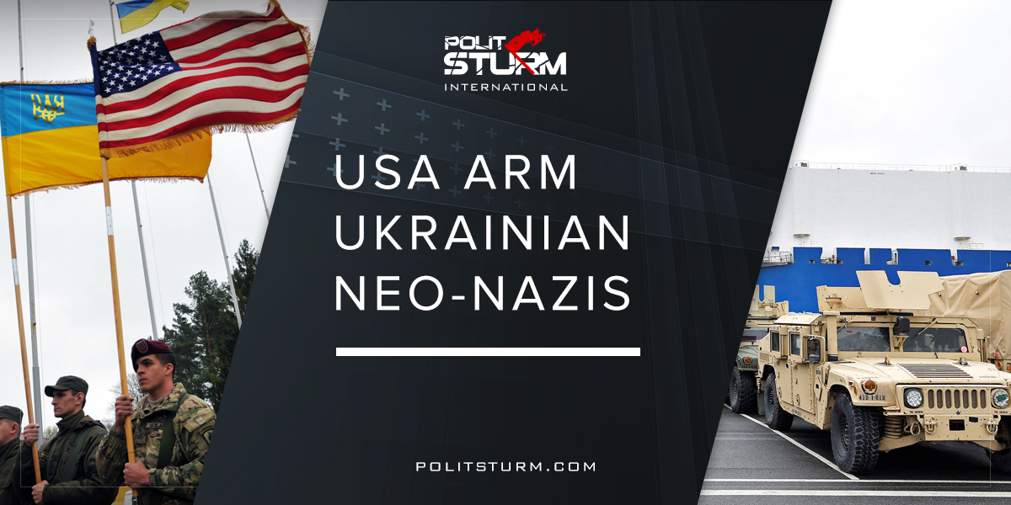

Оригинальная статья
2018-03-06
7 мин. на чтение

In November, an American military inspection team visited the Azov Battalion, a far-right militia operating in Ukraine, in order to discuss logistics and cooperation. Photos released on the Azov Battalion’s news site in late November 2017 show leaders of the group meeting with US military officials, ignoring the Nazi-inspired Wolfsangel patches. Among those present from the “foreign delegation” were Major John Alan Gavrilov, Major Dachan Todorescu, Major Brian Kotter, Sergeant Dmitry Dniprov, Sergeant Samuel Debolt, Ensign John Christensen, Major Denis Laaye and Mr Gerardo Brillantes.
The Azov Battalion is a far-right militia, known for its open neo-nazi views, that has been incorporated into the Ukrainian National Guard. They have been considered the most effective force in countering separatists in Donbass where they are accused of war crimes and the use of torture. Azov operates an underground organization called the “Misanthropic Division” that recruits neo-nazis from various countries in Europe. These volunteers are motivated by the “Reconquista”, or mission to place the nations of Eastern Europe under a white supremacist dictatorship modeled after the Nazi occupation government during World War II.
The battalion’s first commander, Andriy Biletsky, first made his mark on Ukraine as the founder of the “Patriots of Ukraine” which later went on to form the notorious ‘Pravy Sektor’ (Right Sector) that abetted in the toppling of the Yanukovych regime. After becoming a party leader for the group in 2014, he went on to found the battalion as a paramilitary counterforce to the pro-Russian opposition, even going as far as to label them the “Little green men.” When asked about the paramilitary group, Biletsky claimed:
“the historic mission of out nation in this critical moment is to lead the White Races of the world in a final crusade for their survival”… “A crusade against the Semite-led Untermenschen.”
The House of Representatives originally adopted the Conyers-Yoho amendment, a bipartisan admission to the “Department of Defense Appropriations Act of 2015” that specifically blocked the training of the “Ukrainian neo-Nazi paramilitary militia ‘Azov Battalion’” in June of 2015. It was reported by The Nation that the provision was eventually removed from the 2016 defense budget after the Pentagon lobbied the House Defense Appropriations Committee, claiming it was unnecessary as funding was already prohibited under the law. The law in question, the Leahy Law, though, only prohibits funding for groups which have “committed a gross violation of human rights” which most of which have not, and is, of course, up to interpretation. The restrictions do not limit support for a group based on ideology. When asked, U.S. officials have denied any support for the battalion.
Since then, a wide variety of international observers have noted the transfer of heavy weapons going to the Azov Battalion. When Texas-based AirTronic announced a $5.5 million dollar contract with an “Allied European military customer” for PSRL-1 rocket propelled grenade launchers, it was presumed the European client was the battalion after the group revealed the weapons on their website. The pro-Russian military analysis site Southfront later published a leaked contract for 1/10th the original price between AirTronic and Ukrainian arms dealer for distribution to the country’s militias.
The Simon Wiesenthal Center, an organization for countering anti-semitism and hate politics, recently prevented the battalion from holding a meeting in Nantes for recruitment purposes.
“This step is hardly surprising to anyone who has been following the growing danger of Holocaust distortion in post-Communist Europe, and especially in the Balkans, Ukraine and Hungary,” said Efrain Zuroff, head of the Wiesenthal Center’s Jerusalem branch. “In recent years, the United States has purposely ignored the glorification of Nazi collaborators, the granting of financial benefits to those who fought alongside the Nazis…”
In late-January 2018, the Azov Battalion organized in Independence Square in central Kiev, marching in formation with lit-torches. The manifestation, featured in their newest propaganda video, consisted of 600 members of the battalion pledging to clean the streets of alcohol, drugs, and gambling. Their oath included a pledge to protect the nation when government cannot help Ukrainian society.
“We will not hesitate to use force to establish order that will bring prosperity to every Ukrainian family.”
Few western media outlets have covered the neo-nazi front organization, and even less-so, the United States’ support in the form of military arms and equipment. A video produced by NBC shows summer camps held by the “controversial” battalion in which children as young as 9 years old are taught “patriotic” songs and firearms training, and given military style training. In the video the children are shown on a bus chanting in unison, “We shall recover Crimea and then Kuban, and we’ll chase away the Moscow skunks.” The video makes no mention on their openly neo-nazi views, focusing on the Russian “oppression” Ukraine has been subject to for “the last 100 years”. Their “radical” views mentioned by NBC are simply their distaste for “foreigners” and “immigration.”
Politsturm:
Putting aside all other criticisms of capitalism, one of the real dangers of this anti-human economic system is that it is the promoter not of democratic systems as we have been told to believe, but anti-democratic, authoritarian and fascist regimes. This may come as a surprise to many, but the capitalist class has been instrumental in supporting the various forms of fascism in the 21st century.
During the times of the Great Depression, Italian capitalists supported a general policy of austerity to rejuvenate the economy; raising taxes on the lower classes, cutting social services, and providing subsidies for big business, however, what prevented this from happening was the large union presence. The original Fascists, Mussolini’s Nationalist Fascist Party, were supported by the Italian bourgeoisie because of their dedication to crushing the left using extralegal violence and banning opposition parties and newspapers. Many foreign capitalists at the time admired Mussolini for how he “made the trains run on time.” On his sympathies for the Italian dictator, Winston Churchill wrote that “in the conflict between Fascism and Bolshevism, there was no doubt where my sympathies and convictions lay.”
A similar phenomenon happened in Germany where despite their anti-capitalist rhetoric, capitalists, small business owners, professionals, and protestants voted for Hitler’s National Socialist Party while the working poor and unemployed voted en masse for the Communist Party (KPD) and Social Democrats (SPD). Once in power, the Nazis privatized state-owned enterprises in various sectors such as steel, mining, banking, public utilities, shipyards, ship-lines, railways, etc. Many social and labor-related services once provided by the state were handed to private party-held organizations. During the war, Kodak, Alcoa, Rockefeller’s Chase Bank, ITT, Coca Cola, United Fruit, General Electric and other well known American corporations supported the Third Reich. General Motors under Alfred Sloan built transport vehicles for the Third Reich, claiming about 40% of all automobile sales. The Ford Motor Company’s German subsidiary, Ford-Werke, produced military vehicles for the Germans with consent from the headquarters in the states and following the commencement of war used slave labor from captured POWs. IBM provided Germany with technology that was used to help transport holocaust victims to their death. The New York headquarters directly controlled their Polish subsidiary (literally across the street from the Warsaw ghetto) which leased punch card machines used to “calculate exactly how many Jews should be emptied out of the ghettos each day” and to transport them to the camps efficiently. Thomas Watson, the chairman of IBM, was awarded the Order of the German Eagle in 1937.
There was indeed a growing Fascist movement in America as well that took hold during the Presidency of Franklin Roosevelt. Irenee du Pont was a known racist, fascist, an advocate of eugenics, and a supporter of Hitler’s Nazi regime. Before the war, he used General Motors to finance and recruit for the Black Legion terrorist organization that fire-bombed union meetings, murdered union organizers, jews, and communists. The American Liberty League was set up by members of the du Pont family (The 7th richest family in the US at the time). It included Irénée, Pierre, and Lammont du Pont, as well as the top executive of du Pont, Robert Carpenter, former DNC chairman John Raskob, GM President Alfred Sloan, former Democratic presidential candidates Al Smith and John Davis, the President of the National Steel Corporation Ernest Weir, President of Sun Oil Company J. Howard Pew, and General Foods Chairman E. F. Hutton. The group went public in 1934 with the intention of fighting radicalism, defending property rights, and upholding the constitution based on the model set by the French fascist organization Croix de feu (Cross of Fire). Their plan was to arrange for the recruitment of 2 – 3 million members, including many army veterans of the first world war, and to overthrow the Roosevelt government in a military coup, led by famed war veteran Smedley Butler. Instead, General Butler refused and brought the plot to the attention of President Roosevelt and the House Special Committee on Un-American Activities, however, because Roosevelt had been heavily demonized as being a “communist”, the DuPonts were never summoned before the committee.
While many liberals today wish to lump the various “Fascisms” with that of the Left, the historical record shows that the disease that is Fascism is a product of bourgeois ideology and supported by the business elite. In finding a scapegoat in minorities, immigrants, religious groups, or foreigners, the capitalist class can provide itself with an authoritarian state that will protect the needs of capital, resorting to overt violence to protect it from those who would seek to overthrow it, those who face the continued oppression of the capitalist system.
So as economic crises become worse, the elite turn more and more to the far-right, manifested today in the populist parties targeting immigrants, muslims, and people of African descent. Far-right eliminationist rhetoric has moved from the dark corners of the country to the mainstream media in the form of propaganda channels like Fox News and Breitbart where racism, sexism, conspiracy theories, warmongering, far-right apologism, and fear all take center stage.
How does this involve Ukraine? Azov is useful to the American elite because they are willing to do what is necessary to counter the pro-Russian forces in the East regardless of any consideration for human rights. In the long-term imperialist struggle between American and Russian capitalists, a weakened, destablized Ukraine or a full-fledged anti-Russian state on the border of the Russian Federation puts Russia on the defensive and serves to open up a section of the Russian sphere of influence to Western capital. Yet a contradiction lies in the fact that America’s foreign policy that usually justifies itself as a promoter of “freedom” in the abstract is giving aid to the worst forms of authoritarianism. America’s role in the destruction of Yemen, the arming of “moderates” in Syria, and the CIA-backed coup that ignited the Ukrainian civil war, have all been ignored by the mainstream media, covering them as if the American state were simply an innocent bystander. Azov is only the latest ally in its inter-imperialist conflicts and if it serves their interests, they will use them further.
Sources: 1, 2, 3, 4, 5, 6, 7, 8, 9, 10
Text Sources
“How the Allied multinationals supplied Nazi Germany throughout World War II.” Excerpts from Trading With the Enemy: An Exposé of The Nazi-American Money-Plot 1933-1949 by Charles Higham and The Coca Cola Company under the Nazis by Eleanor Jones and Florian Ritzmann. https://libcom.org/library/allied-multinationals-supply-nazi-germany-world-war-2
Bel, Germa. “Against the mainstream: Nazi privatization in 1930s Germany.”
Nishimuta, Yuji. “Nazi Economy and U.S. Nig Businesses: The Case of General Motors”. Kyoto University Economic Review Vol. 66, No. 1/2, 140/141, APRIL/OCTOBER 1996, pp. 25-41
Parenti, Michael. “Blackshirts and Reds: Rational Fascism and the Overthrow of Communism.” City Lights Books: San Francisco. 1997
Rothwell, Johnathan. “Explaining nationalist political views: The case of Donald Trump”. Gallup. 1 August, 2016. http://www.umass.edu/preferen/You%20Must%20Read%20This/Rothwell-Gallup.pdf

Оригинальная статья

