US Cuts Budget For Child Health Insurance
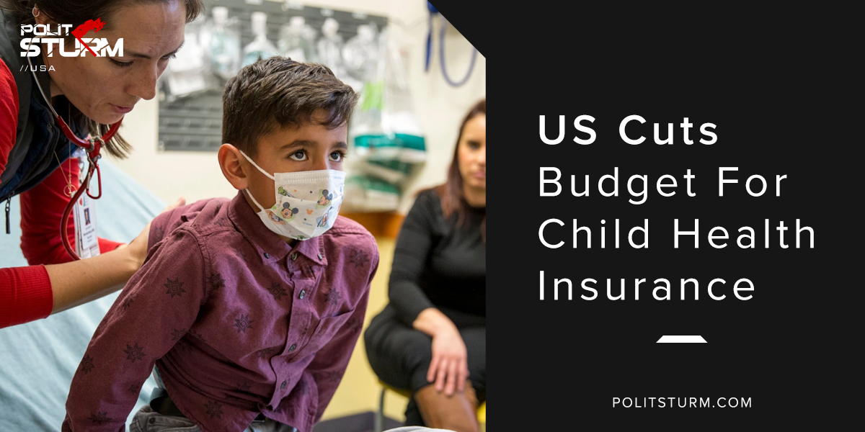

Оригинальная статья
2018-05-12
1 мин. на чтение

President Trump announced on Tuesday that the U.S government will be reducing federal spending by $15 billion. Almost half of the cuts, $7 billion , will be cut from the Children’s Health Insurance Program (CHIP). White House budget director Mick Mulvaney has insisted that the program would not be hurt by the budget cut.
The CHIP program is important because it provides low-income children access to quality health insurance. The program is specifically intended to provide insurance to children whose family income is too high to be covered by Medicaid, but too low to afford private health insurance.
Mulvaney has insisted that these are target cuts that only eliminate the “egregious” and “obviously unnecessary” spending. For the capitalist class, government spending that benefits low income people is considered to be unnecessary.
Since the government of the United States represents the dictatorship of the bourgeoisie, it does not serve the needs of the working class nor is it designed to. We have repeatedly seen that the government does not consider tax cuts for the incredibly wealthy to be “egregious” or “obviously unnecessary”.
The end result of this budget reduction for the CHIP program will be reduced medical coverage for children. American children living in poverty who have no control over their family financial situation are the victims of this budget cut. This outrageous cut is just further evidence that bourgeois parliament does not serve the interests of the working class, but rather the ruling capitalist class.
Sources: 1, 2

Оригинальная статья

