Turkey Committing War Crimes in Rojava
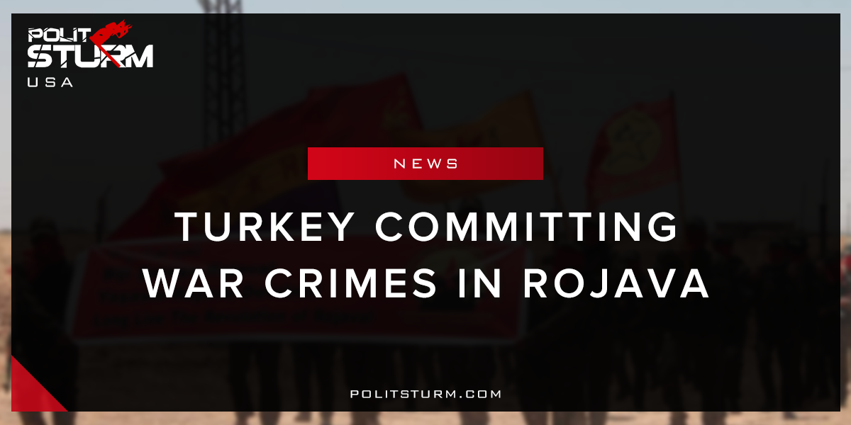

Оригинальная статья
2018-04-11
2 мин. на чтение

It has been reported by ANF News that countless Kurdish men and women have been abducted in the recently occupied city of Afrin. This is occurring in the midst of a campaign to cleanse the city of Kurdish influence. There are accounts of rape, torture, murdering civilians in the street, and looting shops and houses.
“They have entered our houses and took all our valuable belongings since the day they came. They took all the gold, white goods and everything else away loading them on trucks. Then they gathered the people who remained in the city, and separated men and women in different areas. We were hearing the screams of women. I do not know what they did to them. They tortured us men, saying “you are supporters of terrorists, we will take all your belongings and women.”
Of those missing are dozens of young girls believed to be held captive and gang raped by Turkish and allied jihadist thugs. A mother looking for her missing 14-year-old child said that “what was done in Shengal is being done here now. The whole world must see this vileness.” Shengal is in reference to Daesh’s occupation of the city of Shengal where jihadists carried out systematic rape.
The children are believed to be held in certain houses in the city center where they are subjected to sexual assaults by Turkish soldiers.
“They are keeping our children here. They have settled in the houses in that area and are not allowing anyone to approach there. What ISIS did in Shengal is being done here now. Our children are held captive and they are raped by the gangs. The world must see this vileness.”
Another Arab citizen stated that he had witnessed soldiers rounding up the girls;
“A gang leader from the Turkish-affiliated Hamza Brigade is touring the neighborhoods and gathering young girls. They are taking these girls to the houses on Vilayat Street, presenting them to Turkish officers and gang members.”
Ironically named, “Operation Olive Branch”, Turkish armed forces along with jihadist allies successfully took the city of Afrin on March 18th. The point of this exercise is to put to rest any hopes for an independent Kurdish state. This dehumanizing brutalization of women that the Turkish military have undertaken is exactly the kind of patriarchal violence that kurdish feminist organizations have been struggling against. The only way one could commit such a deplorable act of violence would be if he considered his victim to be less than human. Kurdish women, as such, have the pain of being demonized twice, defined as the ‘other’ as an enemy ethnic group and an inferior to men. We can only hope that the perpetrators will find swift justice and Afrin will be liberated from the hands of these imperialistic dogs.

Source: 1

Оригинальная статья

