Toys R US Workers Fight Investors After Bankruptcy
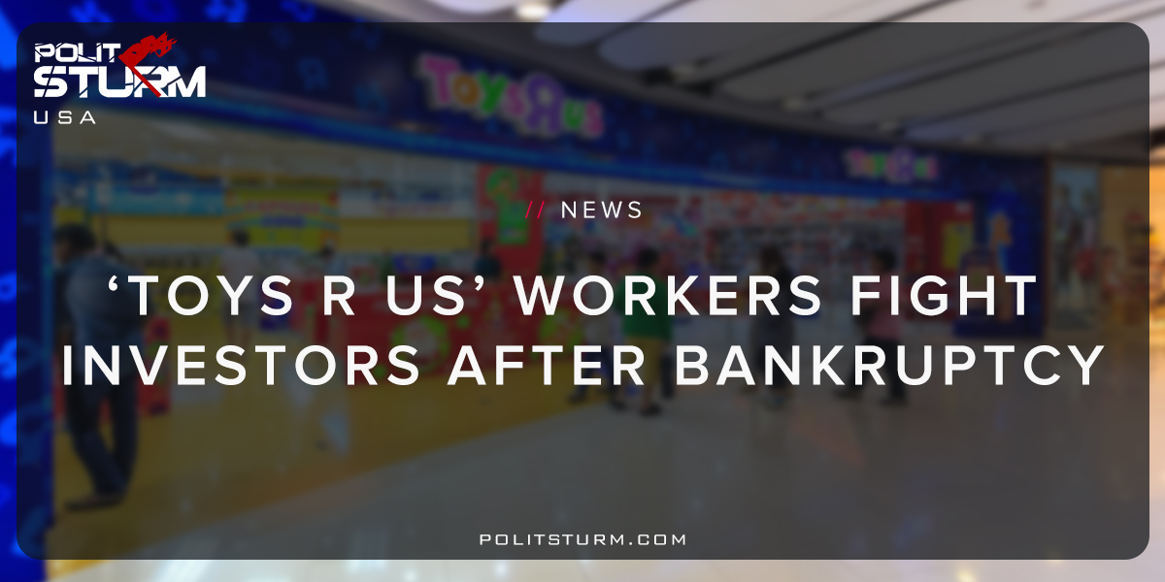

Оригинальная статья
2018-07-23
1 мин. на чтение

Workers for the toy retailer ‘Toys R Us’ are fighting to get a hardship fund from the bankrupt firm. This fund would help employees deal with the traumatic consequences of being laid off and displaced from their jobs. The company was made private when it was purchased back in 2005 by KKR, Vornado, and Bain Capital.
After the buyout, Toys R Us accrued $5 billion in debt which led to the company’s bankruptcy. Since the company was run into the ground by private investors, the workers have lost their jobs and are now fighting for recourse.
Those familiar with the negotiations have said that Vornado is refusing to work with employees and has shunned the discussion of providing any benefits to the displaced workers.
As a result of the liquidation, 30,000 employees have lost their jobs and they are also not receiving the severance packages they expected. Employees were blindsided by the bankruptcy and are now facing a precarious situation of possible unemployment.
Toys R Us has generated billions in profits for private investors since the leveraged buyout in 2005 and now the workers are facing the negative consequences of the bankruptcy. Companies like Bain Capital are notorious for purchasing companies via leveraged buyouts, generating profits for investors and ultimately bankrupting the companies in the long run.
The demise of Toys R Us shows how a small group of oligarchs are profiting off the misery of the working class. The displaced workers are forced to fight tooth and nail for basic necessities while billionaire investors profit and move on to the next “investment opportunity”. The capitalist economic system is ultimately the root cause of the suffering and misery faced by the global working class.
https://www.ft.com/content/cb23c76e-8a20-11e8-b18d-0181731a0340

Оригинальная статья

