To Elect or Not To Elect: On the Recent Presidential Election in Russia
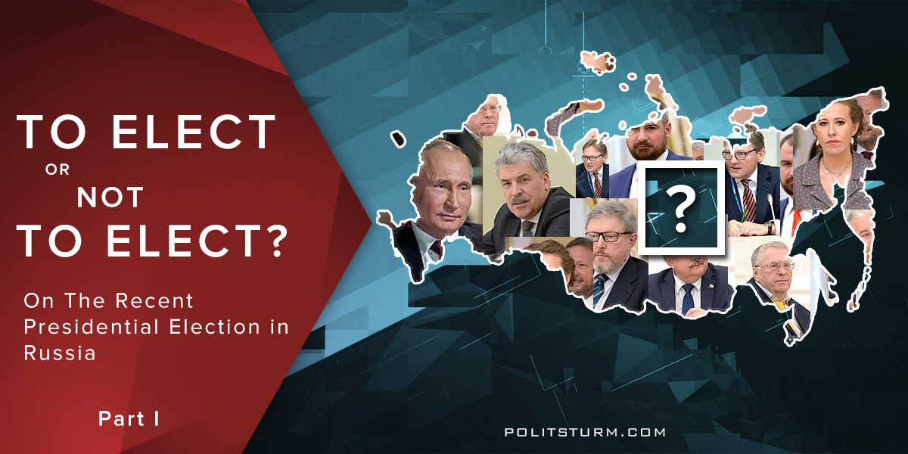

Оригинальная статья
2018-03-26
5 мин. на чтение

On 18 March the Presidential Election was held in Russia. Due to this fact, we at Politsturm decided to write an article that could help Western leftists to understand the political climate in Russia, peculiarities of the election in Russia, its results, and the Russian communists’ attitude to the presidential election.

Peculiarities of Russian elections
Before we proceed to the 2018 election, we’ll briefly tell you about Russian elections in general.
Unlike the traditional American two-party system, in Russia the government has established a one-party system for the last 5 years. The ruling right-center party “United Russia” whose leader was (and actually is) Vladimir Putin holds the majority of seats in the parliament and forms the government, and official opposition parties (in fact they are all puppet) don’t have any real influence.
Let’s look at the result of the last parliamentary election. In 2016 “United Russia” got 343 seats out of 450 (76.22%). It’s followed by the Communist Party of the Russian Federation (the opportunistic organization with patriotic rhetoric which supports the government and has almost completely deviated from Marxism), which earned 42 seats (9.33%); the Liberal Democratic Party of Russia (the rightwing populist party; its rhetoric is similar to that of Trump) got 39 seats (8.67%) and the party “A Just Russia” (the center-leftists) took 23 seats (5.11%). Some minor parties gained 1 seat each, but there is no point to describe them asthey aren’t popular.
Voter turnout was 44%. There is no determined level of participation which is necessary to attain in Russia. That’s why all elections there are legitimate.

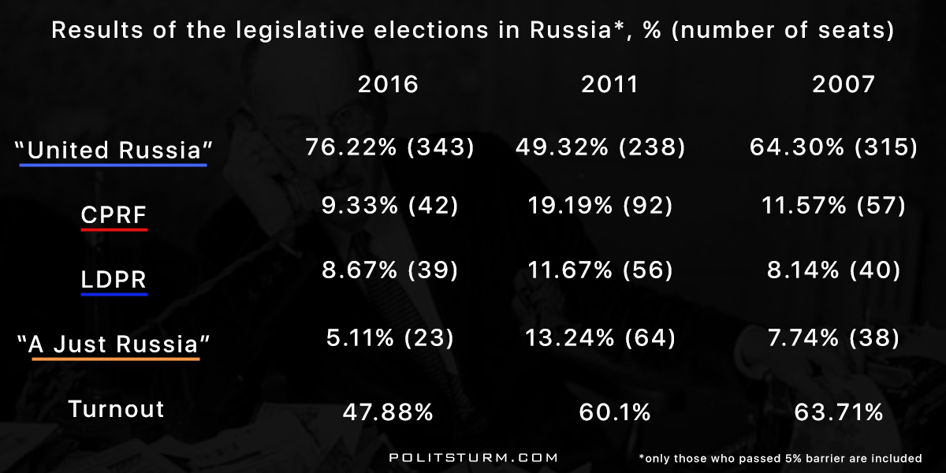
Putin always wins the presidential elections (though, in 2007 the office of President was occupied by Dmitry Medvedev, Putin’s teammate in “United Russia”). Putin’s usual main rivals in the elections were Gennady Zyuganov ( the CPRF chief) and Vladimir Zhirinovsky (the LDPR chief). Vladimir Putin is convenient for bourgeoisie, because his powerful public image was created long ago. He was always presented as “people’s man”, “national leader”, “the Russia’s redeemer from the horrors of the 1990s” and “the opponent of American aggression”. His image is very close to that of Trump, and especially Erdogan in the fact that they both are semi-dictators and reactionaries playing the role of “the national leader”.
The typical traits of all Russian elections are:
- 1. Indifference of the majority of Russians;
- 2. The arrangement of a high turnout by forcing everybody who is somehow connected with the government to vote (officials, students, police and army);
- 3. Puppet opponents are anticipatorily represented as the “wrong choice”;
- 4. A large quantity of violations (such as ballot stuffing and carousel voting);
- 5. And the win of “United Russia” in the parliamentary elections and Putin’s win in the presidential ones.
Using the political machinery, the absence of class-consciousness among the Russian masses and the puppet “opposition”, capitalists have been steadily retaining power and plundering the workers for over 25 years. The natural wealth of boundless Mother Russia belongs to a handful of oligarchs who have made huge fortunes. At the same time, the life of the working people is getting worse and worse: the number of poor is growing, prices are rising, unemployment is rising, and the number of hospitals and schools is declining.
Contrary to the Western media, Russia has not become a “communist empire of evil.”, and Putin is not a communist. During Vladimir Putin’s third term (2012-2018) the common capital of the Russian billionaires, the most part of whom made a fortune in 90s privatizing the former Soviet property, increased from $155 billion to $186 billion. In 2016 0.1% of the Russian population owned 62% of the national wealth. From 1994 to 2012, 1,341 trillion dollars were illegally exported from Russia – more than from Mexico for 42 years!
Russian capitalists plunder the people of Russia with a truly Russian scope. Putin for them is only a screen that was pulled out of the bowels of the Kremlin in time to replace Yeltsin, who had discredited himself. And, of course, they will not clean it.
As in any other bourgeois country, the election in Russia is a show that capitalists arrange to give the people the illusion of choice. All Russians know what they will end up and who will be elected again. But this year the bourgeoisie decided to diversify the elections somewhat…

The 2018 presidential election
In 2018 the situation concerning the election changed a bit.
Firstly, keeping in mind the extremely low turnout in the 2016 parliamentary election, the government aimed not only to get the majority of votes for the current President, but to provide maximal turnout to create the illusion of the honest and transparent election.
Secondly, the government tried by all means to entice people into the polling stations for this. They used a lot of techniques from canvassing and increased pressure on state employees to the sale of food at low prices just near the polling booths.
Thirdly, for the same purpose the traditional list of candidates was changed. We’ll write about the most famous ones, except for Putin, as he is already well-known by western readers.

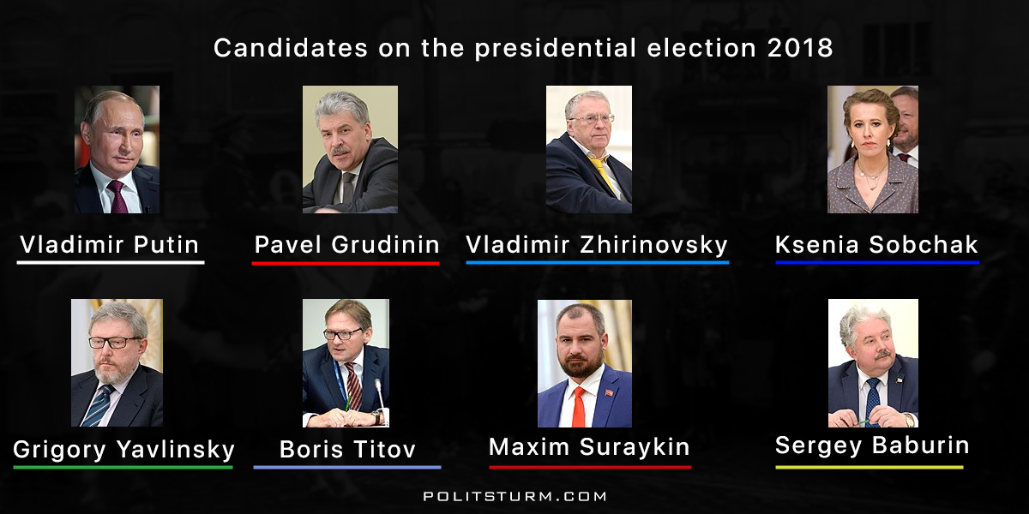
Before the election it was announced that a woman would participate in it for the first time since 2004. It was Ksenia Sobchak who is an oppositionist, TV presenter and an actress, famous for her part in the Russian reality show “Dom-2” (House-2). Her political views can be characterized as liberal (in Russia pro-market neoliberals are usually called “liberals”).
Instead of Zyuganov, who contested elections 5 times and always came in second, the CPRF proposed Pavel Grudinin. He is a businessman and the director of the corporation “the Lenin Sovkhoz” (in the USSR a sovkhoz was a state company; this very company was privatized in 90s, preserving its name) which was advertised as a prospering cooperative, growing strawberries. We’ll recount some more facts about him, as the issue whether to support him or not was rather controversial among leftists.
The LDPR again nominated Zhirinovsky as its candidate. The center left party (which is a mixture of social democracy, “green” policy and liberalism) «Yabloko» («Apple») proposed Grigory Yavlinsky. The liberal conservative Party of Growth put forward the businessman Boris Titov. The CPRF counterpart called “Communists of Russia” proposed Maxim Suraykin. Sergey Baburin was nominated by the national conservative Russian All-People’s Union.
The oppositionist Alexei Navalny is also worth mentioning. For 6 years he has gone a long way from a nationalist to a center left populist. For the last 2 year he has become well-known due to his anti-corruption investigations concerning big officials. But he couldn’t participate in the election because of his criminal record (according to the Russian Constitution a penalized person doesn’t have the right to be a presidential candidate). Despite this, Navalny claimed that he’d stand for the presidential election all the way during his election campaign. At the very last moment when the Central Election Commission refused to register him he announced “a boycott of the election”.
So, there were debates about the election in the left movement. Should communists boycott it? Should they participate in it? If yes, to whom their votes will be given? Who is Grudinin? Is he able to be the “people’s candidate” or is he merely another capitalists’ puppet?
We will look closer to this situation at the second part of our article.

Оригинальная статья

