The Red Menace
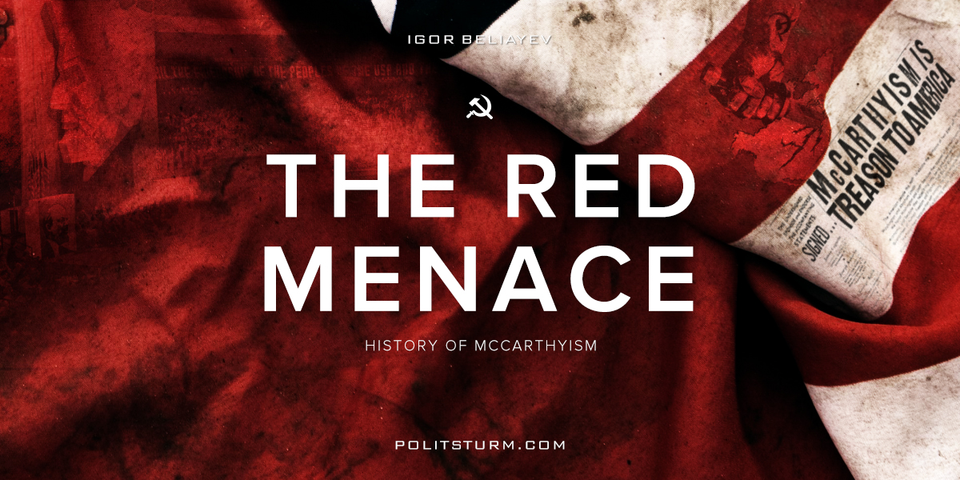

Оригинальная статья
2017-10-20
8 мин. на чтение

When it comes to political repressions, most people immediately remember repressions in the Soviet Union in 1937. Other socialist countries are mentioned less frequently. Even more rarely mentioned are the fascist states. And finally, very few people know about political repressions in the West in general, and in the United States in particular.
There are two periods in the struggle of the U.S. against supporters of leftist ideas. The first peak of the struggle against the Left movement took place in the years 1917-1920, immediately after the October Revolution in Russia. The second happened after the Second World War and continued until the death of Joseph McCarthy, whose name to this day is synonymous with anti-communism.
The persecution of the Left movement in the United States began in 1903, when the law on the deportation of emigrants, sympathetic to the ideas of anarchism, was passed. But this was only the beginning. The real hysteria began before the United States entered the First World War and was intensified by the October Revolution and the Civil War in Russia. There was a national propaganda agency developed during this period called the Committee on Public Information (CPI). The Committee tried to justify the participation of the USA in the Great War in every possible way, exposing it as a “noble campaign for democracy”, while calling for reporting on those who “spread pessimistic statements … call for peace or minimize our efforts to win.” That’s how the repressions against the supporters of peace began.
Hundreds of protesters against the war were thrown in the prison, as well as representatives of the Industrial Workers of the World and the Socialist Party of America. “Patriots” smashed socialist organizations and trade unions. Many laws designed to stop the activity of supporters of leftist ideas are connected with this period, such as: “Incitement to rebellion”, “On immigration” (supplemented to the law “On the exclusion of anarchists”), and “On espionage”. Hysteria went so far that in 24 states any red flags and banners were completely banned, exceptions were made only in several states where they were allowed for pennants of colleges, museums, railways and highways.
In the same period, the number of riots and strikes increased drastically. Encouraged by the victory of the October Revolution, the American working class actively participated in the revolutionary movement. The first to strike were 365,000 steelmakers. Their example was followed by 450,000 miners and 120,000 textile workers. The general strike in Seattle was headed by the Council of Soldiers’, Sailors’ and Workers’ Deputies, created according to the Russian Soviet model. In total, more than 4 million American workers were on strike in 1919. They struggled for increasing wages, improvement of working conditions and the right to organize trade unions.

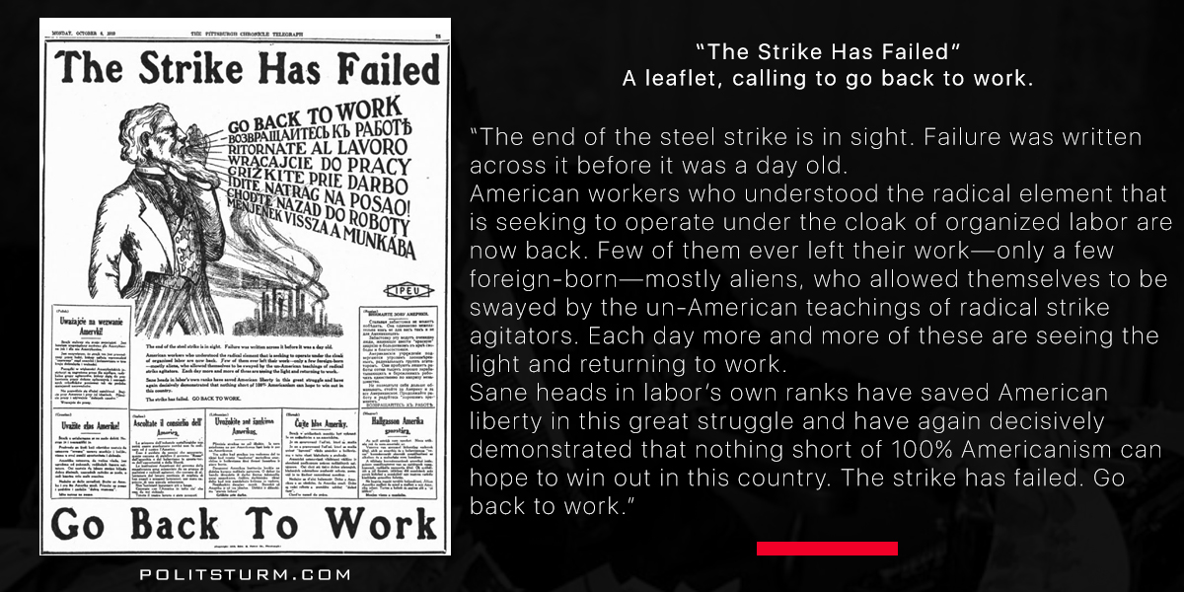
Of course, the bourgeoisie tried to suppress these strikes. When the efforts of strikebreakers and local police were insufficient, the National Guard and federal forces were sent to fight against the workers. The U.S. President Woodrow Wilson called the strikes a “crime against civilization”. The last straw was the news about the planned overthrow of the US President, circulated by Edgar Hoover, which supposedly was due to take place on May 1, 1920. However, this never came to pass. After that, the people stopped trusting many reports about the threat from the left, and the press began to mock the “hallucinations” on the part of the government. So the massive psychosis of the inhabitants of the United States came to naught.
However, the communist movement suffered enormous damage from such a policy. The Communist Party lost 80% of its members with similar effects in other left organizations. Thousands of people were arrested. Many of them were deported from the country. After 1920, the labor movement in the United States was defeated and managed to recover from it only 10 years later with the onset of the Great Depression.

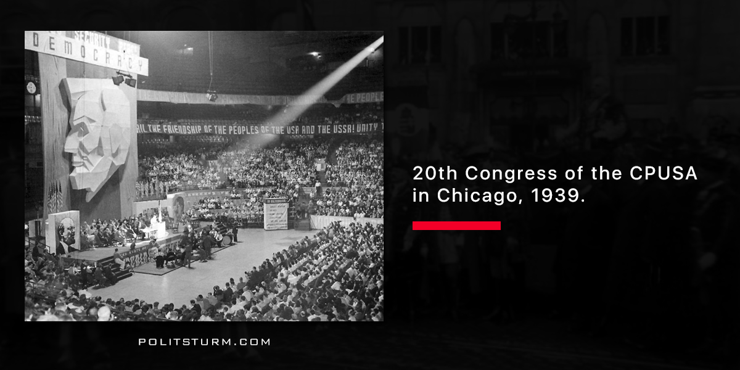
World War II forced a lot of people to change their political views. The Soviet Union, this terrible “fortress of Bolshevism”, broke the spine of fascism. Communists were the main driving force of resistance in Europe and Asia. The largest imperialist countries, the United Kingdom and the United States, who were previously leading a consistent and furious anti-Soviet policy, entered into an alliance with the USSR because of the German threat. At that time Anglo-American capitalists restricted their anti-communist agitation while the Soviet propaganda focused its attention on joint victory over the Third Reich.
But by the end of the war everything had changed. Both the Anglo-American imperialists and the Soviet leaders understood that the common enemy — Nazi Germany — had little time left, and after the collapse of German imperialism the confrontation between capitalism and socialism would be but a matter of time. After the death of Franklin Roosevelt Harry Truman became the president of the United States. He took a much tougher position against the USSR, satisfying American capitalists who were afraid of the “red plague”.
It is not surprising that with such a president, who was expressing the general mood of the capitalist class, relations with the USSR began to deteriorate sharply. The justification for the renewed repression were the statements by former members of the Communist Party of the United States that Soviet intelligence agents infiltrated the state apparatus during and after the war.
The fear of Soviet espionage intensified even more after the creation of a nuclear bomb in the Soviet Union. In 1947, Harry Truman signed Decree No. 9835, which created the “Program for verifying the loyalty of federal employees”. This program was designed to investigate the affairs of employees and dismiss them in case of disloyalty. After the victory of the Communists in China and the outbreak of the Civil War in Korea, a danger of nuclear war arose. In the summer of 1950 the Rosenbergs were arrested and were charged with committing espionage for Soviet intelligence. They were sentenced to death. This attracted the attention of the press and the public. The question of whether the Rosenbergs were actually engaged in espionage or not is still up for debate. Then, in the 1950s, the movement of McCarthyism, named after its founder, Joseph McCarthy, begins.

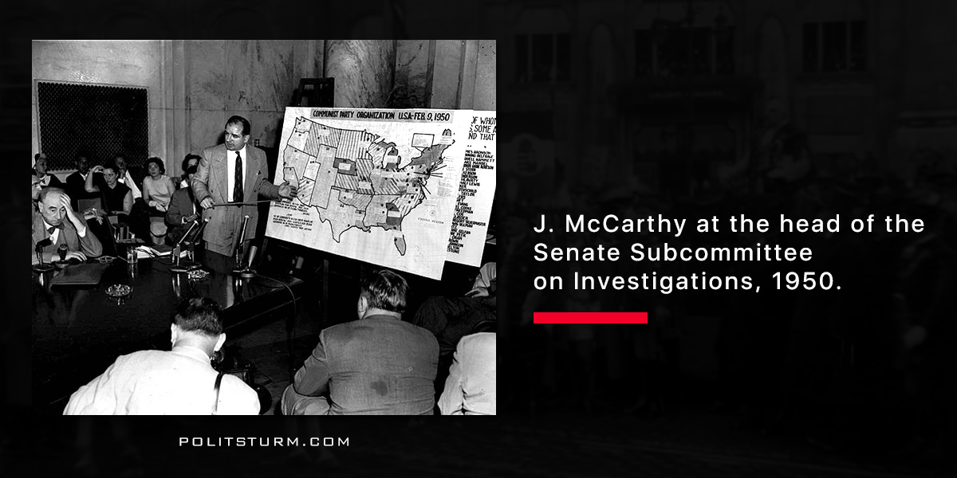
Joseph Raymond McCarthy was born in 1908 in Wisconsin. In 1935 he had got a law degree and in 1939 became a district judge of his state. In 1942 he volunteered for the US army. He advocated the easing of sentences for the Waffen-SS members convicted for the murder of American soldiers, and as a result all death sentences were cancelled.
In his speech in honor of Lincoln on February 9th, 1950, McCarthy declared that 205 employees of US State Department were communists. Later on, this list was expanded to thousands of officials. This speech is considered to be the beginning of McCarthyism. And so began the massive destruction of pro-communist literature across the country. In the report of the pro-McCarthyist journal “Counterattack”, 151 artists were identified and accused of having communist sympathies.
The main blow to the communists was the Internal Security Act or the McCarran-Wood Act, according to which the Communist party and other democratic organizations were forced to register as agents of foreign influence. This required these organizations to report all their employees and members, as well as their financial and organizational activities. The violation of that act led to a sentence of up to 5 years in prison or up to a $10,000 fine. With the new law the House Committee on Un-American Activities was founded, which was engaged with the practical realization of the basic provisions of that law. The Committee had a huge amount of money which was funded by the federal budget. This allowed them to maintain a large staff of investigators and “experts on communism”. They also used the work of informers, who were working with FBI.
The Internal Security Act forbade entry to the USA all foreigners who were or ever had been the member of communist parties and other people who, as specified in the Act, represented a threat to U.S. security. All communists who didn’t have US citizenship but were actually living in US were to be be deported. The Act also provided for the deportation of any non-citizen person, who defended and promoted economic and political theories incompatible with those that were officially adopted in the country. These alternative theories were considered totalitarian propaganda. The Act was later amended so that only those who took anti-communist positions were able to immigrate in USA.

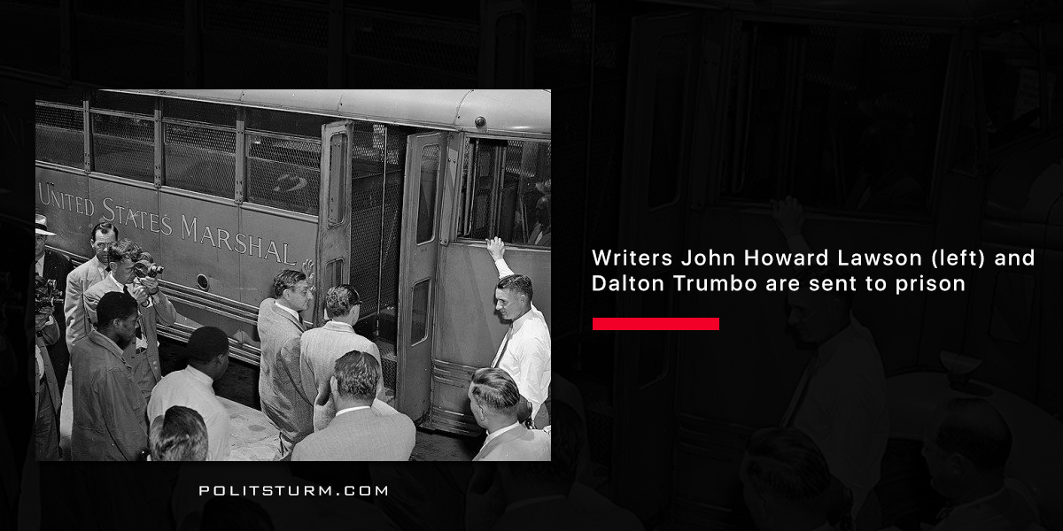
Even Truman, despite being a tough politician, did not share McCarthy’s position. Like many Democrats, he said that McCarthy’s laws were ruining democracy in the United States. Therefore, McCarthy began to seek the support of Dwight Eisenhower, who was a Republican. He led Eisenhower to power in 1952 by utilizing the strengthening influence of television. Now that all the restrictions on the part of the president were lifted, the McCarthyists got into the ruling party, and Eisenhower himself came under their control. Thus, 1953 became the heyday of McCarthyism.
Now McCarthyism began to operate out in the open. The books were burnt. Actors, writers and other cultural figures who got on the “black lists” were forced to migrate from the US, professors and other scientists accused of sympathizing with communism were fired, and the unions collapsed. Blacklists have appeared almost everywhere: in entertainment, educational institutions, in legal affairs and in other areas. Because of this, from 10,000 to 12,000 people lost their work.
In 1954, the 83rd Congress adopted the “The Communist Control Act of 1954”. The Communist Party was deprived of “any rights, privileges and immunities enjoyed by legitimate institutions operating under the jurisdiction of the United States”. This meant depriving the Communists of the right to nominate their candidates in national election campaigns. The 1954 law, like the McCarran-Wood Act of 1950, forbade communists from obtaining a passport, being in the civil service in a federal institution and working for the military. The law extended strict rules to a broader, all-encompassing scope.
However, Eisenhower did not personally share the views of McCarthy. He considered him to be his friend, but politically he was more interested in the support of the Republicans. In 1954, several television stations started a campaign against McCarthy: he was accused of violating civil rights and freedoms. After that, McCarthy was severely criticized, including public condemnation by the president. His last resolution to the Senate was held in 1955 and was rejected by 77 votes to 4. The hearings on his case were completed, and McCarthy himself began to be excluded from public view. With his level of influence decreased, the epoch of McCarthyism ended. McCarthy himself died in 1957 of alcoholism.
It is difficult to calculate the number of victims of the McCarthy policy. Hundreds of people were incarcerated, 10,000 to 12,000 people lost their jobs, many of whom had to emigrate from the country. The most famous victims of McCarthyism are Charlie Chaplin, Albert Einstein, Qian Xueen, Langston Hughes, Robert Oppenheimer, the Rosenbergs, and more than a hundred of the cultural figures. However, with the death of McCarthy, repression of the Communists did not stop and continues to this very day.

Оригинальная статья

