Tesla Lays Off 9% Of Workers
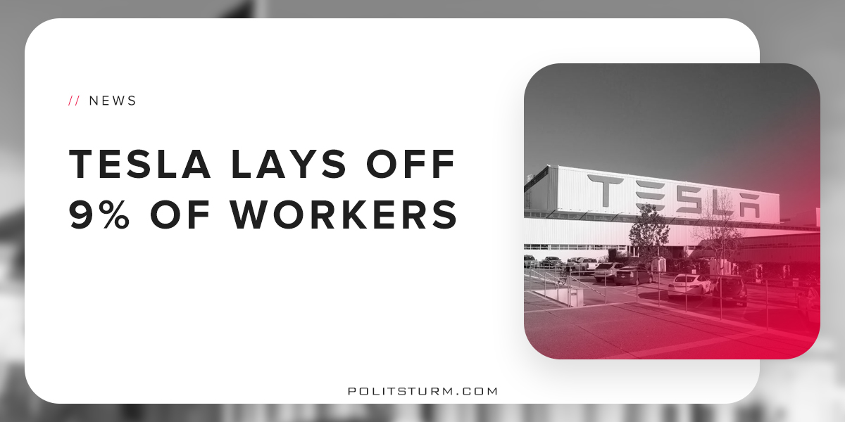

Оригинальная статья
2018-06-22
2 мин. на чтение

Tesla has laid off about 9% of its workforce, accounting to more than 3,000 workers in a recent attempt to increase profitability. In a memo justifying the layoffs, Musk stated that Tesla needs to become “sustainably profitable” and needed to eliminate the “bureaucracy”.
The private investors and board of directors are rather trying to raise short-term profitability by cutting labor costs. Since none of the production staff is being laid off the production targets have not been changed.
This is an obvious attempt by the capitalist class to increase the rate of profit by laying off employees and exploiting the current workforce even more. The language used to justify these layoffs should not deceive workers.
The mission of Tesla is to achieve the maximum profit and provide a financial return to stock and bondholders. As the money market gets tighter and interest rates rise during the end of the business cycle, interest expenses increase accordingly.
This simply means that capitalists who lend money are receiving a larger share of the profits produced by the working class in production. Industrial capitalists, due to the conditions on the money market are forced to pay more money in the form of interest. Companies that produce things, like Tesla, borrow money to finance production.
In Tesla’s own numbers we see this picture. Interest expenses have risen quite dramatically, losses attributable to shareholders are mounting, and the board of directors cut labor to serve the interests of capital. The American mythos of self-reliance and the propaganda of the bourgeois class has convinced some Americans that the interests of capitalists are synonymous with the interests of the American working class.
Former Tesla sales manager Kevin Throop said, “It’s the right thing for the company,” after being laid off. While this may be the right thing for the oligarchs, it is not good for workers. To lump both capitalists and workers into one grouping, called the “company” only serves to hide the capitalists from criticism and dissent.
Rather than being portrayed as a “job creators”, the capitalist class should be seen as beneficiaries and creators of unemployment. Capitalists only hire workers to the extent that they create profit. Since Tesla has been unprofitable, shareholders are simply attempting to achieve profitability by cutting labor costs. The layoffs demonstrate that the capitalists will throw the working class into precarity and unemployment whenever capitalist class deems it necessary.
http://files.shareholder.com/downloads/ABEA-4CW8X0/6239658125x0x979026/44C49236-1FC2-4FD9-80B1-495ED74E4194/TSLA_Update_Letter_2018-1Q.pdf
http://business.financialpost.com/transportation/autos/laid-off-tesla-workers-lavish-unprecedented-praise-on-elon-musk-and-his-vision-as-they-walk-out-the-door#comments-area
https://www.thedailybeast.com/tesla-to-layoff-9-percent-of-its-workers
https://twitter.com/elonmusk/status/1006597562156003328
http://ir.tesla.com/releases.cfm

Оригинальная статья

