Sacramento Pigs Murder Unarmed Stephon Clark
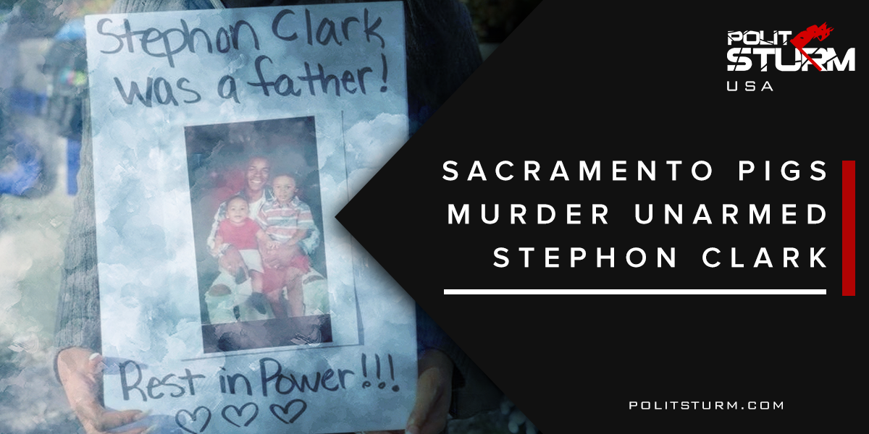

Оригинальная статья
2018-04-05
4 мин. на чтение

On March 18, at 9:20 pm, Stephon Clark, an African-American resident of Sacramento California, was murdered by the two Sacramento police officers who shot Clark 20 times in his grandmother’s backyard. Police reported to his residence while investigating a vandalism complaint. Following Clark into his backyard, with a helicopter flying overhead, officers confronted Clark, telling him to put his hands up, and then immediately after yelling, “gun, gun, gun, gun!” shot him. Meanwhile, Stephon’s disabled grandparents called police after having heard the gunshots, described the noises that they had heard, and were not informed by police that the shots had, in fact, occurred in their own backyard. They only realized when they looked into the yard and noticed their grandson’s motionless body laying on the ground.
Since the beginning of the scandal, we have seen the pigs attempt to cover up Clark’s murder. At first, the account told to the media was that he had a gun and ran at the officers, prompting them to shoot. When no gun was found at the scene, the story was changed so that Clark had a “toolbar”. When nothing but a cell phone was found, the pigs had to retract their second account of the shooting.
It was confirmed by released helicopter and body-cam footage that Clark was murdered with his back turned and unarmed. An independent autopsy of Clark’s body confirmed that he was facing away from the murderers the entire time he was being shot at. He received six entry wounds from the back and one from his left side and none from the front. All evidence points to the fact that Stephon Clark was not a threat to the police officers, yet was murdered in cold-blood.
Adding to the controversy is the fact that officers muted their body-cameras after the shooting and waited five minutes before giving Stephon medical attention. Protesters are demanding prison time for the officers involved.
Hundreds of sympathizers attended the funeral of the 22-year-old father of two. Afterwards, 100 protesters gathered by the city hall, giving speeches and stopping traffic, to protest the murder.
“They didn’t have to kill him like that. They could have waited for back up, they could have called in the dogs. But they didn’t do that.”
Local residents spoke on the poverty and differences in income inequality between their neighborhoods and the richer quarters. The protesters then moved to occupy the city hall, led by Stephon’s brother, yelling “Stephon Clark” and demanding to speak with police chief Daniel Hanh. Protesters could be heard chanting, “You shoot us down, we shut you down!” while struggling with police.
The protest then moved to the stadium for the Sacramento Kings where protesters were met violently by riot police with tasers, batons, and rubber bullets.
Apologists argue that the officers should be let off the hook. Wasn’t Stephon Clark a criminal? Surely the police have a complicated job that warrants them some leeway? Surely, there are a few “bad apples” that cause more harm than good, but not every member of the police force is that way.
Systemic politics, however, trump whatever good intentions one might have and can be the reason why one’s job becomes so complicated.
Consider, first, the whole idea of policing. To a large extent, the police officer’s job is only in existence because of the large inequalities that exist in our society; Crime, drugs, domestic violence, gangs, and rioting all have roots in poverty. These inequalities are a systemic feature that are out of the control of the officer. Personal attributes of certain individuals are meaningless when just doing one’s job means enforcing private property laws that keep the people impoverished; evicting Americans from their houses during an economic slump, removing individuals from the workplace when sacked, and enabling the large corporations whose “dollar votes” override our voice in our democracy. Then there are the secondary roles that support the bourgeois superstructure: putting down popular social movements, deporting immigrants because natives feel economically threatened, and enforcing the bourgeois legal system
The fact that officers shot at Stephon Clark 20 times leads one to believe that a certain amount of ideology played a role in his killing. The fear of the “scary black” is injected into us every time we turn on the local news and see the mugshots of wanted criminals. This stereotype harkens back to the times of slavery and is constantly reinforced as long as blacks are disproportionately left in poverty, justifying the pseudo-scientific ‘natural inequalities’ that racists attribute to non-whites. The fear of the “other” that we ourselves have defined, is what leads to these kinds of massacres.
But then again, maybe there was some form of hard racism apparent in the officers that night. Throughout the investigation, the Sacramento Police constantly brought up the ‘fact’ that Clark had smashed windows to the media (did they forget that Clark is innocent until proven guilty?). This attempt to spin the story in order to demonize Clark, as if criminal activity necessitated death by firing squad without due process, is only an attempt to justify this horrendous crime to onlookers. To shoot an unarmed citizen would be seen as a horrendous injustice, but shooting a “criminal” is, unfortunately, a forgivable action for many Americans as it further portrays the police as “heros” with difficult jobs. The officers involved were able to use this image of the “dangerous black man” to justify his murder.
No matter what “positive” intentions one may have on an individual basis, the role that one plays in a larger oppressive political “machine” will always trump that of your personal feelings. This is why Daniel Hahn, Sacramento’s first African-American police chief, who had goals of reforming police practice, could not prevent the execution of Stephon Clark from happening. What we cannot excuse is not the individual characteristics of certain officers but the class traitors simply “doing their jobs” while divesting themselves of responsibility from all the different forms of social coercion and oppression that they contribute to and expect to be lionized or treated as sympathetic victims of circumstance.
Sources: 1, 2, 3, 4, 5, 6, 7

Оригинальная статья

