On U.S Finance Capital
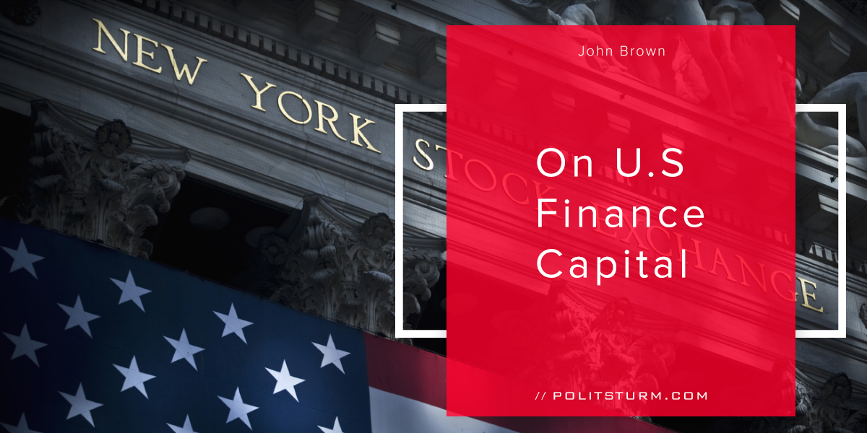

Оригинальная статья
2017-10-16
8 мин. на чтение

I. What is Finance Capital?
In order to fully understand what Finance Capital is we must first successfully define money capital. According to Marx, money capital was as follows:
“…the formula for the circuit of money-capital is: M—C … P … C’—M’, the dots indicating that the process of circulation is interrupted, and C’ and M’ designating C and M increased by surplus-value.” (1)
The capitalist starts with money and buys labor power and means of production on their respective markets. After this step is complete the capitalist has the workers engage in production, and if successful produces a commodity capital with a larger value than what was started with. The last step involves selling the commodities for a profit, thus the tacit assumption that M’>M. This explains how a money capitalist can start with a sum of money and end with a larger sum of money.
II. The Evolution of Money Capital
A successful capitalist is able to take money capital and expand it by exploiting the workers in the act of production. How is this so? Because the worker was divorced from the means of production, he is forced to accept a wage in exchange in exchange for his or her labor power. The capitalist buys labor power for its price (wage), and receives its use value (the production of profit, or surplus value). Through the investment of money capital the capitalist is able to expand production and exploit workers.
In the current era, however, the money capitalist is not necessarily an industrial capitalist.He does not need to be involved in the production of commodities directly. It is possible for an investment banker to invest in production, exploiting workers thousands of miles away or domestically. This was done through the centralization of large banks funneling money into production. In order the accomplish this task large banks were necessary to funnel wages and profits back into production. In the U.S the largest banks are J.P Morgan Chase, Bank of America, Wells Fargo, and Citi.
III. The Role of Finance Capital Domestically
The aforementioned large banks, along with other investment banks such as Goldman Sachs and Morgan Stanley, play a significant role in offering this debt. In order to finance infrastructure, money needs to be raised in the form of bond offerings. This concretely means that money must be lent by those that have it to those who do not. Debt is turned into a commodity in the highest stage of capitalism, giving rise to the absurdity of debt as a commodity. At the surface level it appears as though investors can lend their funds and receive debt repayment and interest. Underlying this fact is nothing more than the direct exploitation of the working class.
As capitalists lend money, they expect to earn a return on their capital. Where is the source of this profit that the capitalists seek? Does this profit fall from the heavens as a gift? Perhaps it is compensation to our industrious capitalists who take such onerous “risks”? As Marxists-Leninists we must look for the objective causes of this phenomenon and not console ourselves with such utter nonsense.
Obviously there is a difference between funds lent to industrial companies (Boeing, Intel, Pfizer,etc) and those lent to governments (local, state,federal). However, the circuit of money capital is exactly the same from the viewpoint of the capitalist and can be simplified to the form:
M-C-M’
Money is taken as the start of the cycle. The next step is the purchase of a commodity, in this case it is financial capital in the form of private or public debt. The holder of the debt is entitled to a stream of income in the form of interest. Bonds have differing maturities ranging from several months to many decades. At the maturity of the bond the investor is returned his initial money investment and has accumulated interest payments over the course of the period. Thus the circuit finishes, and with reinvestment of the initial capital this circuit can occur ad infinitum.
An example of this would be:
M-C-M’-C’-M’’-C’’-M’’’… where M<M’<M’’ and C<C’<C’’
This gives us the form that financial capital takes but it gets us no closer to figuring out the source of the profit, or surplus value. In order to elucidate this We will need to provide examples for both industrial and finance capital.
IV. Industrial Capital
Industrial capital is distinct from other forms of capital because it involves buying labor power and means of production, both fixed and circulating, to eventually produce a profit for the industrial capitalist. Fixed capital refers to the depreciating aspects of production typically held in the production process for more than a year. A building or a machine needs regular maintenance and is fixed in time and space. Fixed capital slowly passes its value to commodities over its life. Circulating capital enters the production process and passes its entire value to the finished commodity. Examples of circulating capital include labor power, raw material, and auxiliary material.
In the creation of profit, the only true source can be the exploitation of labor. If the capitalist buys only constant capital and resells it he can only make what Marx called “profit on alienation”. For example, say a capitalist buys a bushel of apples with a value of $100 for $100 and re-sells them for $120. It would appear as though the capitalist created a profit of $20 out of thin air. The reality is that no new value was created solely through the process of buying and selling. What for the seller represents a $20 gain is a $20 loss for the buyer. The net result of this transaction is a wash. Since all goods cannot be sold above their value, a logical absurdity, this act creates not a single atom of surplus value.
For the industrial capitalist actual surplus value is acquired by buying up labor-power and extracting more value out of the laborers than what is paid for. This unpaid labor represents surplus value for the capitalist class, the lifeblood that spurs their parasitical class tendencies. The flow of industrial capital is as follows:
M-C..P..C’-M’
The capitalist starts with money then buys labor power and materials. Putting the labor power to productive work creates a commodity whose value has been enhanced by the act of production. The capitalist then sells the commodities and has realized a profit and can start the whole cycle again. Suppose the industrial capitalist does not have the money to start the process, what happens then? This is where the financial capitalist can step in…
V. Intervention of Financial Capital
The financial capitalist does not concern himself with the details of production, he is a moneyed man or woman looking to “put it to work”. As Adam Smith and David Ricardo knew, the great predecessors in the field of economics to Marx, capital flowed into the branches of production with the highest rates of profit. Moneyed capital is always in search of the highest rate of profit and thus it flows into those sectors. The financial capitalist creates a contract with the industrial capitalist regarding the terms of lending. The key points are that the money must be paid back in full at a determined date and that a split of the profit must take place between the financial and industrial capitalists. This is called the rate of interest.
The whole of the process takes the following form:
M-M-C..P..C’-M’-M
In this way both the industrial and financial capitalists are able to take “their” cut of the social surplus that is produced by the working class.Lenin perfectly understood this point when he stated “finance capital is the bank capital of a few very big monopolist banks, merged with the capital of the monopolist associations of industrialists”.(3) This brotherhood of bandits including industrial capitalists, commercial capitalists, financial capitalists and landowners exploit the working class for as long as capitalism exists.
VI. Effects of Financialization on the US
Many bourgeois writers in the US have commented on the role of the growth of financial capital in the US. Many claim that finance, real estate, and insurance have sucked the life out of the US economy leading to the de-industralization of the American economy. The American “rust belt” is a shell of its former self. Production has shifted to lower wage countries, such as China. These commentators want to “save capitalism” by reversing the trend of financialization towards and industrial economy. These individuals are severely mistaken. As we have shown, financial capital is merely a form of capital. It is the system of capitalism itself that is failing, not this or that aspect of the system. Anyone with any knowledge of dialectics in the field of political economy knows that money and commodities are a dialectical pair. Disliking only the financial aspect of capitalism is naive because capitalists need to sell their commodities in the form of money to realize a profit!
Capacity Utilization, the measure of the means of production being actively used in the US, has been on a consistent downward slope for more than half a century. (5) It is not the new system of financial capital that has done harm to the American economy, but capitalism itself. Unless the internally contradictory system of capitalist production is abolished America will continue to decline further.
VII. U.S Finance Capital and Imperialism
The United States is the largest investor and recipient of foreign direct investment in the world. The major recipients of this foreign investment are the European Union, Latin America, and Asia, with the European receiving 59% of U.S foreign investment. Exactly where is this money being invested? The vast majority, $2.58 trillion in 2015, is invested in holding companies. (2) In this way, the U.S can obtain voting rights in foreign corporations and influence the decisions of their board of directors. These holding companies exist for the sole purpose of controlling foreign companies and subsuming their interests to those of U.S finance capital. The U.S is thus able to gain considerable influence and control abroad while extracting profit from the global working class.
The preceding shows how U.S finance capital plays the predominant role in extracting profit from foreign foreign business. Finance capital is also able to directly control and subordinate all foreign interests to U.S interests. We must then ask how these extractive tendencies can be maintained over time. The United States military plays the predominant role in maintaining the global capitalist economic system. It is financed through the taxation of the American population and through federal debt held both domestically and by foreign investors.
This can be illustrated through the new budget proposal, entitled “A New Foundation for American Greatness”. This proposed budget for 2018 includes an increase in military spending of $52 billion to bring annual defense spending to a level of $639 billion.(6) Holders of US federal bonds are lending money to the United State government, which in turn uses a significant portion of those funds to establish and maintain its military force. Marx called this type of investment “fictitious capital” because the money is spent on consumption and not necessarily invested directly for profit. It rather entitles the holders of these government bonds to a portion of the future production of the United States. He states:
“We shall now consider labour-power in contrast to the capital of the national debt, where a negative quantity appears as capital — just as interest-bearing capital, in general, is the fountainhead of all manner of insane forms, so that debts, for instance, can appear to the banker as commodities…In all countries based on capitalist production, there exists in this form an enormous quantity of so-called interest-bearing capital, or moneyed capital. And by accumulation of money-capital nothing more, in the main, is connoted than an accumulation of these claims on production, an accumulation of the market-price, the illusory capital-value of these claims.” (7)
The national debt of the United States exists as a fictitious capital that funds the continued operation of the U.S military. This is the true essence of the connection between financial capital and imperialism. The military force of the U.S and finance capital are mutually co-dependent upon one another. Finance capital directly funds the U.S military and is imperative for its continued existence through the sale of Treasury Bills, Notes and Bonds. Likewise, the U.S military, through force, maintains the conditions necessary for finance capital to expand and exploit the global working class. The Securities and Exchange Commission, in charge of regulating the securities markets in the U.S, says “The mission of the SEC is to protect investors – including investors in municipal securities – maintain fair, orderly, and efficient markets, and facilitate capital formation”(4). Their stated purpose is to make sure investors recoup with investment and are successful in receiving profit.
Insofar as the U.S military and its global counterpart NATO is able to expand and encompass the entire globe, it creates the conditions through which finance capital can flow into non-imperialist countries and exploit those populations. This explains how the capitalist class is able to use finance capital as a major weapon in establishing the supremacy and growth of capitalism. In the age of imperialism, capitalism must be maintained by force and will not be dismantled without force.
Source
1. https://www.marxists.org/archive/marx/works/1885-c2/ch01.htm
2. https://fas.org/sgp/crs/misc/RS21118.pdf
3. http://www.readingfromtheleft.com/Books/Classics/LeninImperialism.pdf
4. https://www.sec.gov/news/studies/2012/munireport073112.pdf
5.https://fred.stlouisfed.org/series/TCU
6.https://www.whitehouse.gov/sites/whitehouse.gov/files/omb/budget/fy2018/budget.pdf
7.https://www.marxists.org/archive/marx/works/1894-c3/ch29.htm

Оригинальная статья

