On the "utopianism" of communism
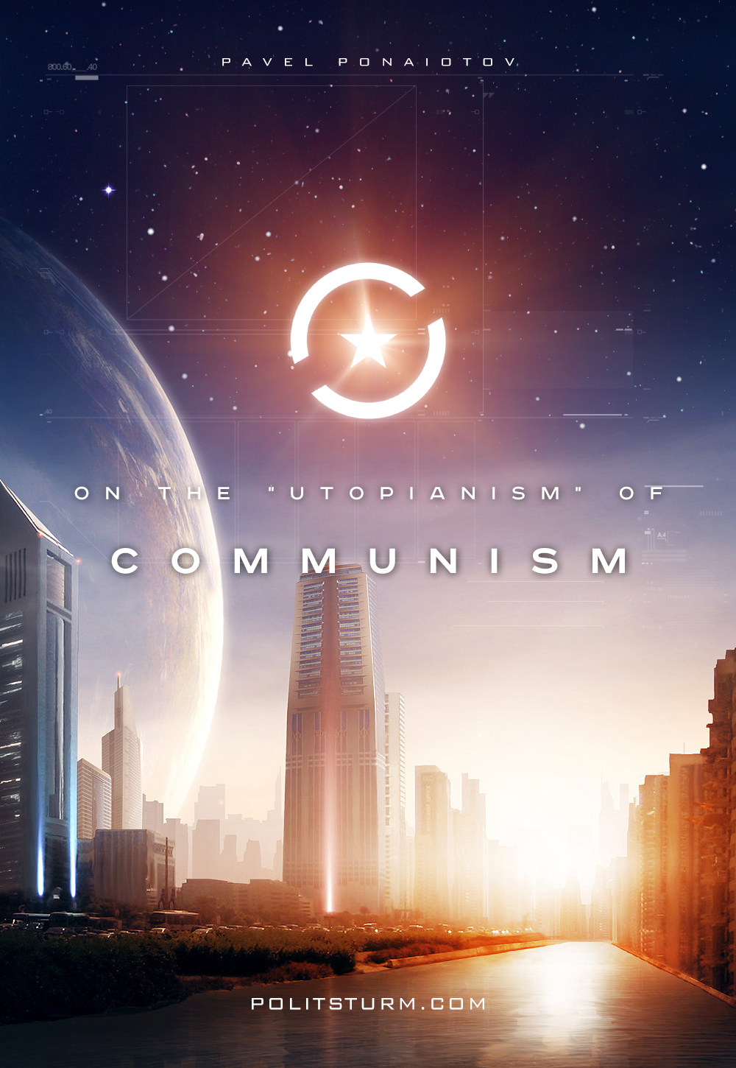

Оригинальная статья
2017-09-13
5 мин. на чтение

«This communism of yours is an utopia, it is impossible to achieve it in practice” — a frequent exclamation among the various members of the bourgeoisie and even from “a common man”. Such thesis can be heard from a learned professor, a great politician, a famous writer, an ordinary worker or a student who does not understand the essence of the matter. Each time this cry is accompanied by appropriate vocal theses, which form a concrete foundation of the “utopian communism». Said foundation can be summarized in four simple theses:
– Post-scarcity is impossible;
– It is impossible to change “human nature” (in the sense of eradicating selfishness, profit, greed, etc.);
– Equality is impossible;
– It is impossible have a complete absence of problems and contradictions.
The extent to which the label of “utopia” in regard to communism is consistent can be judged from this foundation. Therefore, it is proposed to deal with the above theses, while reflecting, among other things, on the notions of bourgeois swine about communism.
Look around you and you will see what unprecedented heights our science and technology has now reached. Complex computers (conventional computers and quantum supercomputers), robots, drones, cybernetic systems, 3D printers, biomechanical prostheses, automated farms, clean energy, genetic engineering, giant transnational production, etc. And how many of this unprecedented technology is still at the conceptual stage, in the form of ideas, sketches. And this is not the limit, not the apogee of development, but only its dawn. These technologies combined together with their maximum development and use are capable of giving a real abundance, moreover, a sustainable abundance.
The very nature of these things, as well as their inherent potential, requires from us a completely new set of productive and economic relations, a completely different approach to social production. This technique will ensure the social nature of production (on the one hand, an overwhelming number of people are involved in the activity, on the other hand, the goods are produced for use by all the masses of the people, for the “mass consumer”, so to speak),but with a particular private method of appropriation and distribution of the goods, i.e. under private ownership, there can be no talk of any abundance, for the owner needs profits, not the common good. The profits are obtained through a scarcity, not an abundance.
Therefore, technology requires from us to bring the method of distribution of goods in accordance with the nature of production itself, namely, the taking of the means of production in public ownership. The direction of technological development and production itself would be for the needs of all people, and not to quench the thirst of the capitalist desire to accumulate money and live a lavish life of luxury. Therefore, it is necessary to unite the now fragmented anarchic production into a single centralized complex and conduct production on scientific principles. The combination of the latest technology with a scientific approach and new economic relations in its development will lead to a sustainable abundance. Of course, this will not be done immediately, the day after the social revolution. This is undoubtedly a long, arduous and thorny path, at which we will encounter severe resistance, we will make many mistakes, etc. And the result of this thorny path can be enjoyed only by our progeny.
A lot of people talk a lot about so-called “human nature “. As a rule, it includes selfishness, greed, profit, individualism, competition, etc., that is — all the defects of exploitative social formations. The permanence of the human’s personality, of the “nature of man”, and therefore — the thesis “communism is impossible”, is postulated, because from this angle it is just “the dreams of naive romantics”. However, even K. Marx and F. Engels revealed that the human consciousness — world view, ideas, values, ideals, sacred things, attitude to oneself, to other people and nature as a whole, is changing with the changing set of productive and economic relations, with changing in the mode of production, as well as from them.
Individualism and competition, for example, come from private property, while collectivism and cooperation are from common property. This situation is clearly illustrated by ancient Europe, where there was a Roman republic with competition, individualism, greed, etc., and there were Celtic and Germanic tribes, where co-operation, collectivism, sincerity and altruism have dominated. At the same time, physiology with psychology have proven that the personality, the so-called “nature” of a person is a transitory, non-permanent phenomenon, changing constantly. Personality (ideology, values, ideas, ideals, attitudes towards oneself and the world around them, the behavior model) is formed and determined by the environment in which one lives and interacts with, and the type of your activity influences your personality.
Therefore, the Communists believe that by changing the relations of production, people principally change themselves, and by changing the environment cardinally, the people will change radically. And the social environment is nothing more than a socio-economic formation with a mode of production, with a certain set of production-economic relations in the foundation. In place of competition and individualism that derive from market relations, private property and the fragmentation of production, there will come consciousness and benefactor, cooperation and collectivism, originating from common property and joint production. And when already in the course and on the way to achieve abundance, in which (as it turned out) there is a necessity, we will do away with such things as avarice, greed, hatred, crime, laziness, parasitism, selfishness, etc.
When it comes to equality, as usual, speculations and scarecrows come out, creating a substitution of concepts. Hence the understanding of equality as a universal total equalization, and for many this isn’t limited to the equation of incomes.
However, Marxism defines equality as, firstly, the equality between nations, between the sexes, and so on and so forth, and secondly, the real equality of opportunity. Equal access to labor, instruments of labor, production and socio-political bodies. Marxism aspires to equality, under which everyone has so many blessings and such benefits as and which he needs; where everyone works and works freely, with enthusiasm. Given the possibility of creating a sustainable abundance, this state of affairs is possible to implement in practice, in the long term. But socio-political equality (as between different peoples, between men and women, etc., and in terms of lack of exploitation, equality of opportunity) is achievable in the short term.
Because utopia is an ideal state of affairs, an idyll devoid of any problems and contradictions (and many people think that communism is precisely this ideal society) following statements are usually thrown: “under communism there should be no problems, everything should be perfect, and this is impossible … “. However, Marxism asserts that it is far from the absence of any problems or contradictions under communism. Relying on a general and detailed study of nature, we understand that the driving mechanism of development lies precisely in the contradictions, that there are constant problems facing the organism. They are everywhere and always present.
Marxism teaches us that in a communist society there will be and should be problems, there must be certain contradictions. However, firstly, these problems, these contradictions (and their forms) will be radically different from what is available today, they will be completely different. Secondly, all arising problems, maturing contradictions will be solved, will be overcome. There is no such problem that can not be solved within the framework of the communist system, and a new, more complex problem will arise to replace one solved problem, thanks to which the communist society will not be able to stamp on the spot, staying in a once and for all frozen form. As you can see, the foundation is not at all from the concrete of knowledge, but from the sand of conjectures and logical errors. The construction of “communism is impossible, communism utopia” collapses, like a sand castle. We perfectly see how and how the communist system really is possible.
The era of utopian communism came to an end when K. Marx and F. Engels started joint activities, criticizing former socialists for the haste of their conclusions, for the lack of a positive doctrine of change and the thirst for constructing and detailing the future of the system without an in-depth study of the state of affairs of today. And it was thanks to the discoveries made by Marx and Engels that communism acquired a scientific basis through the universal laws of development, the laws of the historical process and the nature-perspective of the existing, capitalist system. Communism ceased to be the product of a dreamy mind that designed a better future, but became a scientific forecast of the future, carefully derived from a study of reality.

Оригинальная статья

