On The U.S. Contribution To The Victory Against Germany
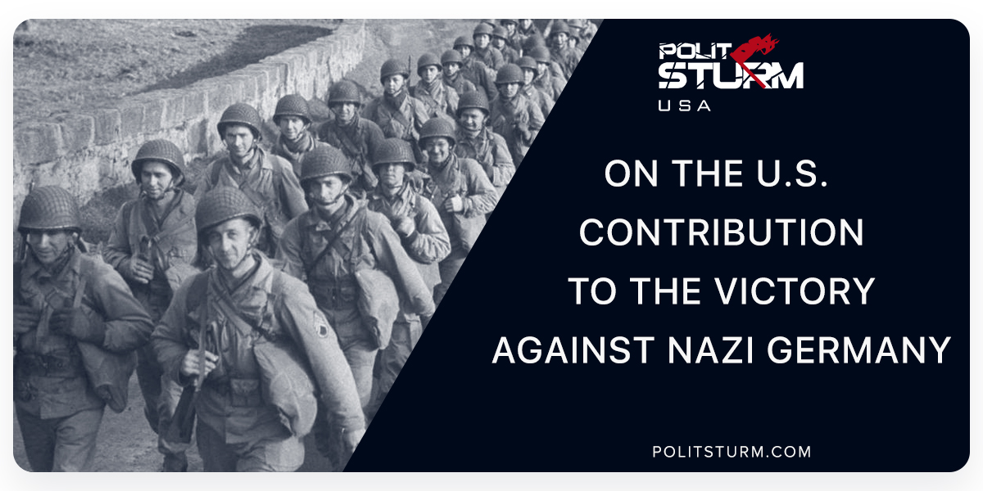

Оригинальная статья
2018-05-10
5 мин. на чтение

In a recent poll asking Americans and Europeans “which country did the most to defeat the Nazis” both the Americans and the British have overwhelming majorities of people who believe that they did the most to defeat Hitler and the other European countries are split between Britain and the United States. The truth of the war effort has been buried underneath a mountain of Cold War propaganda and Hollywood films that glorify the western front and Pacific campaign fought by the Americans. In 1945, the polls showed the opposite result. In France, for example, 57% of the population chose the USSR (US – 20%, UK 12%).
From the time that the Nazis launched Operation Barbarossa on June 22, 1941 to the creation of the second front on July 6, 1944, the Red Army took on near the full brunt of the superior German war machine by themselves. The Western Allies, who were happy to struggle from the sidelines, only provided the Soviet Union with desperately needed supplies, and yet even these fell short of what was originally agreed upon in July 1941. In February 1942, Lend Lease Administrator Edward Stettinius wrote to John McCloy: “As you are aware, the relations between this Government and the Soviet Government have been constantly disturbed by the failure of this Government to meet its commitments.” In March 1941, Roosevelt expressed his worries about the loss of the Eastern front with the collapse of the Red Army: “I do not want to be in the same position as the English [,who] promised the Russians two divisions. They failed. They promised them help in the Caucasus. They failed. Every promise the English have made to the Russians, they have fallen down on.” He later on went to tell MacArthur:
“I find it difficult to get away from the simple fact that the Russian armies are killing more Axis personnel and destroying more Axis materiel than all of the other twenty-five United Nations put together. Therefore, it has seemed wholly logical to support the great Russian effort in 1942 by seeking to get all munitions to them that we possibly can.”
In September 1941, Stalin requested the opening of a second front in Europe and the deployment of twenty-five to thirty divisions to the Eastern front to alleviate pressure on Soviet forces. Stalin questioned the sincerity of past British agreements, saying, “By her passive attitude Britain is helping the Nazis. Do the British understand this? I think they do. What is it they want? It seems they want us to be weakened.” In fact, many on the Allied side did not approve of support for the Soviet Union, such as Harry Truman who stated that, “If we see that Germany is winning we ought to help Russia, and if Russia is winning we ought to help Germany, and that way let them kill as many as possible.” In early 1942, plans were drawn up by Eisenhower for an invasion of Western Europe and an agreement was made between the American and Soviet leadership to launch the second front in 1942 in exchange for a 60% decrease in promised American aid.
Meanwhile, the Soviet Union had repelled once thought invincible German war machine in the suburbs of Moscow in the Winter of 1941-2. Casualties for the Germans were near 170,000 while for the Soviets, they were in the millions.
Complaining of not having enough troops for an invasion of Europe, the British decided to go against the agreed upon front with Molotov and instead invade the periphery, Vichy-occupied North Africa in an attempt to reclaim colonial lands lost to Rommel in Tobruk. American military officials continued to push for the second front, but eventually caved and endorsed the TORCH campaign in North Africa. At this time in the war, the Soviets were confronting the Germans head-on in the most bloody battle in history, Stalingrad. This six-month battle was to be the turning point in the war when the Soviets would successfully defend and then push the Germans to retreat. Hitler was quoted as saying, “The God of War has gone over to the other side.” Casualties on the German side came near to 700,000 while the Soviets sustained losses of over 1.1M people.
During this time, there came a significant rise in pro-Soviet feeling. Soviet “heroism” became a prominent theme throughout the war. Hollywood began producing films with positive images of the Soviet Union in Mission to Moscow, North Star, Song of Russia, Three Russian Girls, and Days of Glory. General MacArthur conceded that the Red Army had achieved “one of the greatest military feats in history.” Secretary of State Cordell Hull commented on the Soviet people’s “heroic struggle” against the Nazis. Even the bourgeois press had positive views of the Soviets during wartime. New York Times correspondent Ralph Parker noticed how “rapidly and how completely the Russian people” had “adapted themselves to war conditions.” Journalist Leland Stowe wrote that “In 13 months the Russians have suffered more than 4,500,000 in killed, wounded, and prisoners… probably six or seven times Great Britain’s losses in nearly three years of war… 20 times the total American casualties in the first World War.” New York Times main daily book reviewer Orville Prescott, wrote that…
“The vast armaments, the fighting skill and magnificent courage of the Red Army may prove to have been the decisive factors in the salvation of the human race from Nazi slavery… Our debt of gratitude to the millions of Russian soldiers who have fought and died in this war and who will continue to do so is beyond estimation or expression.”
The Allies would then move north to the soft underbelly of the Axis forces, Mussolini’s Italy, while the Soviets pushed their way through German-occupied Central Europe. Throughout most of the fighting up to this point, the Red Army had regularly engaged more than two hundred German divisions while the Allies rarely engaged more than 10 at a time. Churchill famously admitted that it was the Red Army who “tore the guts out of the German military machine.” It was at this time, when momentum was moving towards Berlin, that the Allies decided to launch the second front July 6, 1944. Over 100,000 Allied troops and 30,000 vehicles landed in Normandy to reclaim France and head for Berlin before the Soviets arrived.
All in all, the Soviet Union lost an unfathomable 27 million people during the war, 10 million of which were military personnel, compared to 350,000 British and 300,000 American losses. In many individual battles, the Soviet Union lost more men than the Allies did during the entire war. The Belorussians had lost more than 25% of their entire population, whereas Armenia, Azerbaijan, Kazakhstan, Latvia, Lithuania, Russia, and Ukraine lost at least 10% or more. At the same time, the USSR suffered immensely from the Holocaust; The Nazis exterminated an estimated 32% of the Jewish population of the Soviet Union with Estonia (38%), Latvia (74.7%), Lithuania (88.1%) taking exceptional losses. While the allied effort in the war cannot be denied despite what many Russian nationalists would say today, the idea that the Americans or British somehow “won” the war, contributing more than the millions of lives and resources that the Soviet Union did, is a gross exaggeration and a pseudo-historical account of history that is used by those with a nationalist agenda in the capitalistic world today to denigrate those who chose the path contrary to the forces of capital. As New York Times correspondent and foreign affairs columnist C.L. Sulzberger wrote:
“In terms of misery and suffering, of malady and disaster, of wasted man hours in a land where work is glorified, the loss is incalculable. It cannot be gauged by the scarcely touched peoples of America. It cannot be measured by the sadly battered people of England. It perhaps cannot be fully realized even by the masses of Russian people themselves.”

Оригинальная статья

