New Department of Homeland Security Rule Targets Immigrants
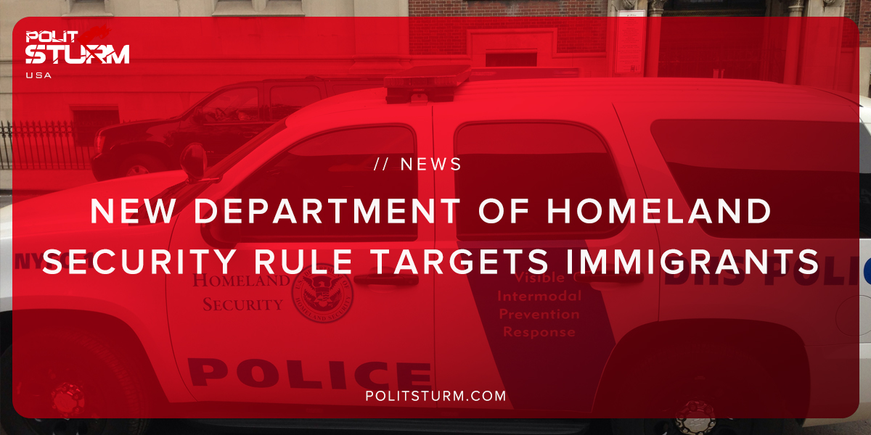

Оригинальная статья
2018-09-01
1 мин. на чтение

The Department of Homeland Security has proposed a change that would dramatically change how the United States Customs and Immigrations Services (USCIS) determines eligibility for being legally admitted into the United States.
The core of the change relates to setting a dollar threshold for receiving public benefits. For example, under the proposed rule the applicant would have to prove that they have not received public benefits over a certain dollar threshold or for a certain period of time.
The proposal would place an increased burden on applicants to prove that they will not become a “public charge”.
This proposal is nothing more than an attempt by the Trump administration to attack a vulnerable demographic within the United States, namely immigrants. Whereas wealthy individuals, landlords, and religious organizations are not considered a fiscal burden on society, immigrant communities face increased and unfair scrutiny.
This diversionary tactic is often used by the ruling capitalist class in order to divert attention from the failing capitalist system onto marginalized groups. Workers and people of conscience should not be deceived. Capitalists are more than willing to abuse immigrant labor inside the country then attack the same laborers as being “illegal”. This proposal is not an attempt to be fiscally responsible, but rather is a thinly veiled attack by the capitalists and their supporters on immigrants.

https://www.dhs.gov/sites/default/files/publications/18_0921_USCIS_Proposed-Rule-Public-Charge.pdf

Оригинальная статья

