Native People’s Healthcare: The Next Broken Promise
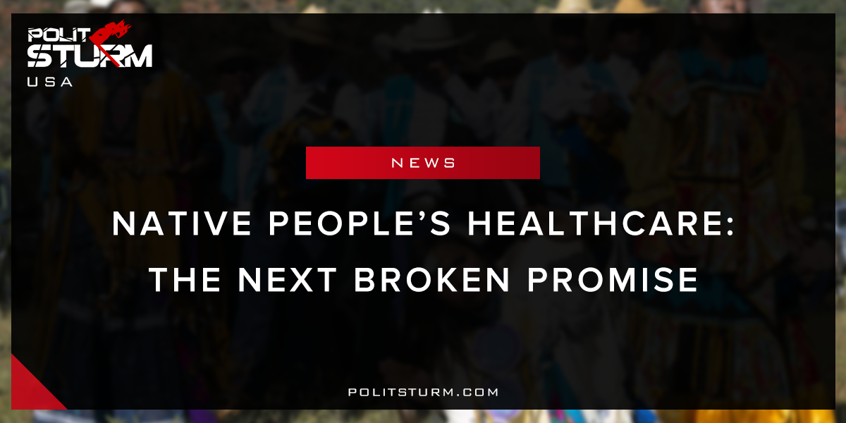

Оригинальная статья
2018-04-29
2 мин. на чтение

President Trump is challenging the protections for Native Americans that legally oblige the United States government to provide healthcare to Native American tribes. Tribal leaders are suing for an exemption from Medicaid rules in at least ten states that would require recipients of the program to be employed as well as the penalty for those without private coverage under Obamacare’s individual mandate.
The Trump administration has argued that the tribes are a race rather than separate governments and exempting them from work requirements would be illegal. The administration’s lawyers stated that, “HHS believes that such an exemption would raise constitutional and federal civil rights law concerns.” Tribe members, however, have pointed out the “racial preference” makes no difference because agreed-upon treaties from the early days of the United States protect the tribes as separate governments under the constitution.
After reversing the decision to postpone construction of the Dakota Access pipeline near the Standing Rock Indian Reservation, in which he has invested, Donald Trump is seeking to eliminate what few rights American Indian tribes still have left. If a precedent is upheld that Native American tribes are indeed a “race” and not a sovereign government, this will put in jeopardy the rights of all tribes to exist independently of the United States.
What happens when an economic system, that must continually expand, comes into contact with communal societies? Conflict. The history of the genocide of the native peoples of North America is littered with war, ethnic cleansing, forced integration, racism, and economic privation because economic interest, dictated by the market, created the desire to expand. During the initial colonization of the “New World”, the rich saw the continent as an investment opportunity while the poor came as the footsoldiers of capital, free or in indentured servitude, to start a new life. The allure of the endless tracks of ‘free’ land was appealing to them. Would this expropriation of native land have occured if it were not for an economic system that creates such primitive and aggressive interests through desperation, competition, and lust for personal power over others?
This struggle continues to this very day. Leonard Peltier and the American Indian Movement were put down by the FBI. Oil markets are still threatening tribes with the construction of pipelines. American Indians are still living in abject poverty on the little land they have been allotted. The American policy of expropriation of native has not ended but is instead in continuity.
Sources: 1, 2, 3, 4

Оригинальная статья

