Massive Cuts Proposed to Student Aid Programs
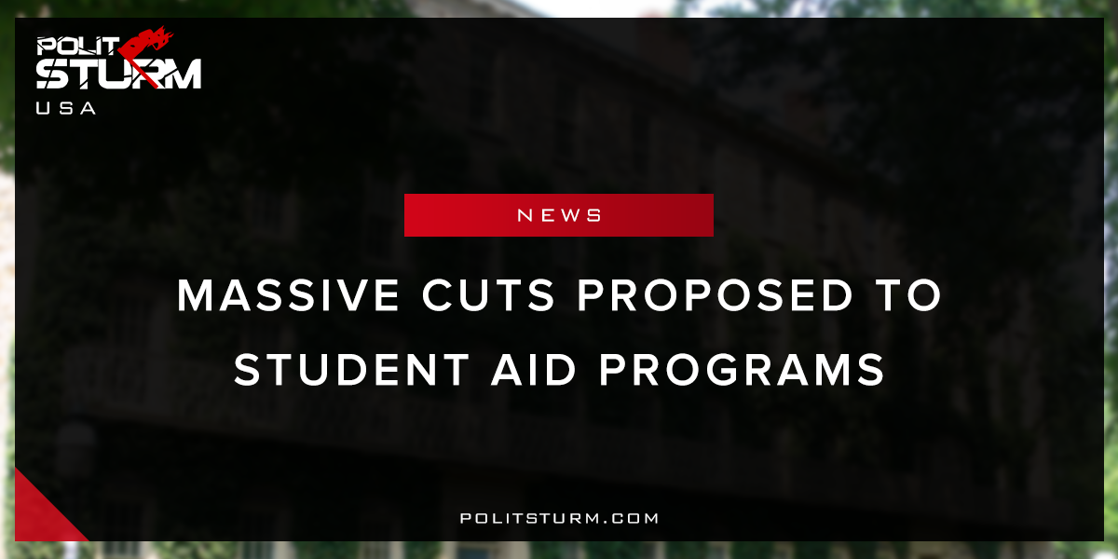

Оригинальная статья
2018-04-23
1 мин. на чтение

The 2019 Budget proposal by the Trump administration entails massive cuts to student aid programs. One of the most significant cuts is the elimination of Public Service Loan Forgiveness program. This program allows students who pursue a career in public service to receive loan forgiveness after 120 qualified payments on a repayment plan. This proposal will hurt workers, such as teachers, who devote their lives towards the betterment of society. The bourgeois parliament finds it more appropriate to deliver tax cuts to billionaires and debt bondage for the mass of workers.
Another key strategy of the Trump administration is to reduce the amount of funding Department of Education receives. The proposed budget for the department is set to decrease 10.5% from 2017 levels. The “balanced budget” of fiscal conservatives reduces programs that support the working class and enacts programs that benefit the oligarchs.
The working class has enormous student loan debt and declining public educational opportunities. Students are regularly burdened with student loan payments for up to 30 years, draining their income and siphoning interest payments to lenders.
The policies of the oligarchy are deeply rooted in class interests. The privatization of education will undoubtedly allow “opportunities” for investors to reap benefits. The capitalist system punishes the mass of American workers for trying to improve their skills and knowledge while a caste of idle parasites collect interest payments.
It is entirely possible for Americans to cut out the proverbial middleman, or more appropriately the parasitic capitalist, from the educational system. Under capitalism the American public education system will continue to decline as the working class suffers increased payments for mediocre outcomes.
https://www.whitehouse.gov/wp-content/uploads/2018/02/budget-fy2019.pdf

Оригинальная статья

