Lenin on two sides of capitalism
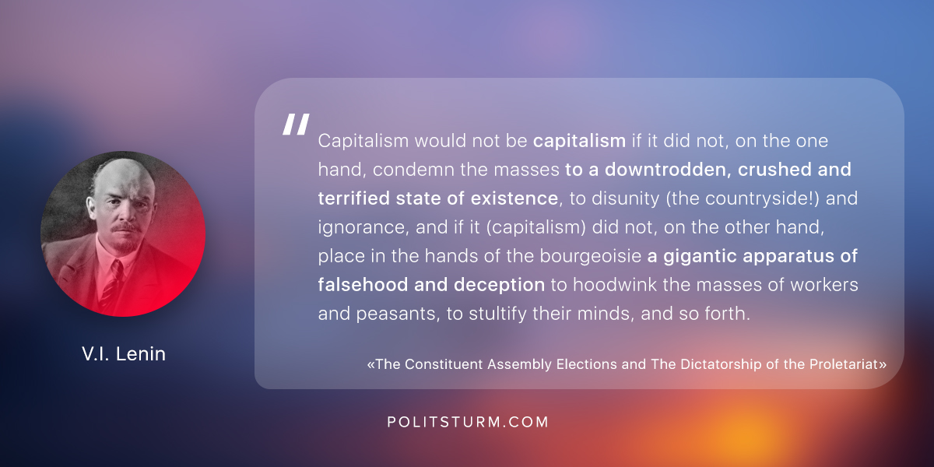

Оригинальная статья
2018-07-10

“Capitalism would not be capitalism if it did not, on the one hand, condemn the masses to a downtrodden, crushed and terrified state of existence, to disunity (the countryside!) and ignorance, and if it (capitalism) did not, on the other hand, place in the hands of the bourgeoisie a gigantic apparatus of falsehood and deception to hoodwink the masses of workers and peasants, to stultify their minds, and so forth.”
V.I. Lenin, “The Constituent Assembly Elections and The Dictatorship of the Proletariat”

Оригинальная статья

