Lenin on Reading Marx
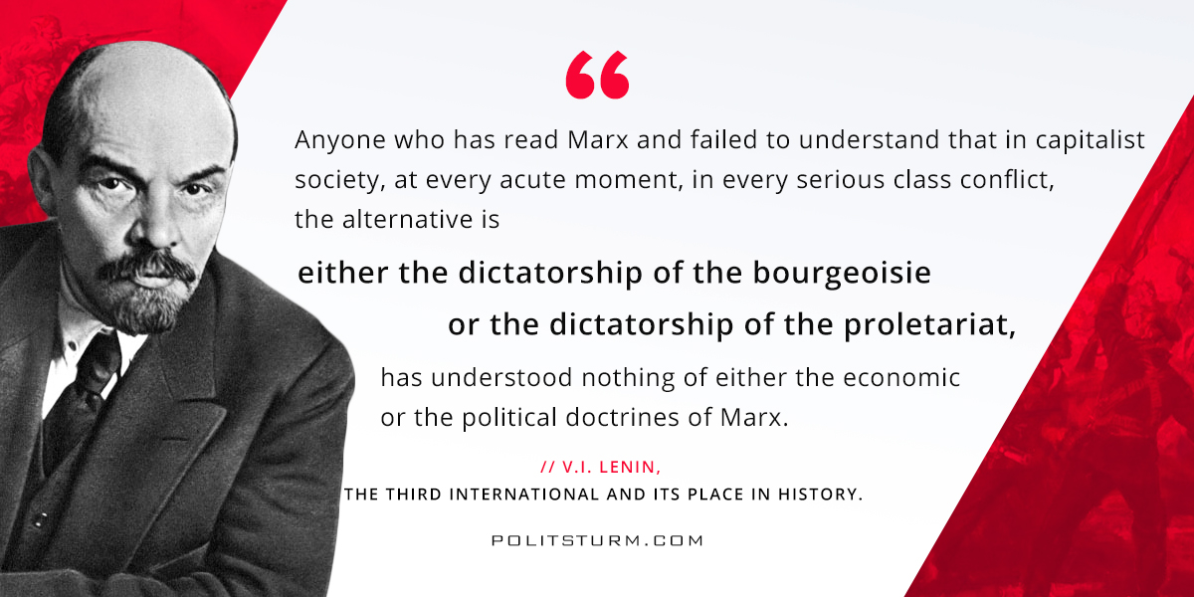

Оригинальная статья
2018-04-12

“Anyone who has read Marx and failed to understand that in capitalist society, at every acute moment, in every serious class conflict, the alternative is either the dictatorship of the bourgeoisie or the dictatorship of the proletariat, has understood nothing of either the economic or the political doctrines of Marx.”
V.I. Lenin, The Third International and Its Place In History.

Оригинальная статья

