Lenin on decaying capitalism
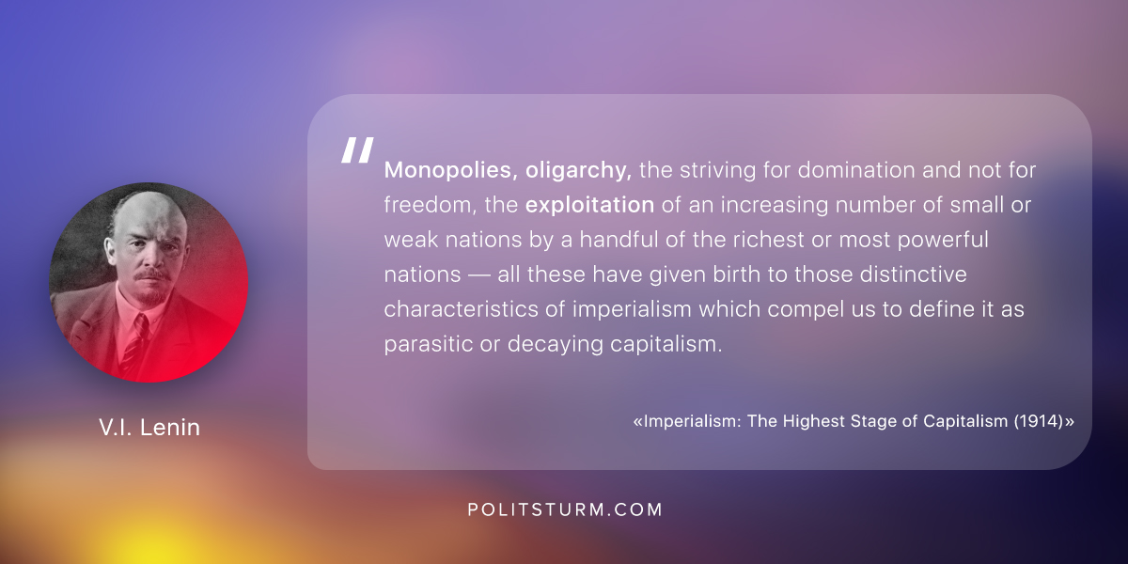

Оригинальная статья
2018-07-24

Monopolies, oligarchy, the striving for domination and not for freedom, the exploitation of an increasing number of small or weak nations by a handful of the richest or most powerful nations — all these have given birth to those distinctive characteristics of imperialism which compel us to define it as parasitic or decaying capitalism.
Lenin, Imperialism: The Highest Stage of Capitalism (1914)

Оригинальная статья

