43% Of American Families Struggle to Afford Necessities
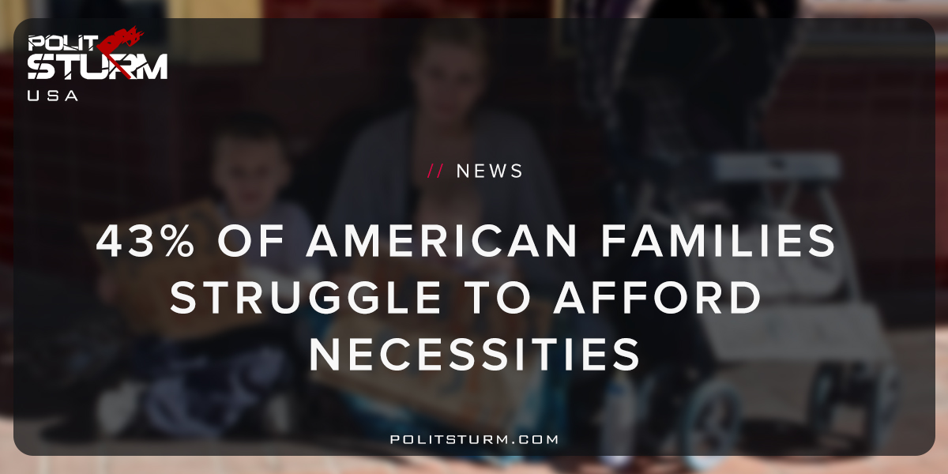

Оригинальная статья
2018-05-25
1 мин. на чтение

A study was recently released by the United Way’s ALICE project which shows 43% of American households cannot afford housing, food, child care, health care, and transportation costs.
ALICE is an acronym for Asset-Limited Income Constrained but Employed and is supposed to refer to people who are working but are still unable to financially afford life’s necessities. In reality, the workers are “asset limited” and “income constrained” because they are only able to survive by working and receiving a wage or salary.
By definition the working class is “asset limited”, because the majority of assets are owned by the capitalist and landlord class, which represents an oligarchy.
The stocks, bonds, mutual funds, private corporations and real estate are overwhelmingly owned by the parasitical caste of oligarchs, while the working class struggles to obtain the bare necessities of life.
It is entirely possible for the American working class to have adequate health care, stable employment, and to put food on the table for their families. Only due to the irrationality of the capitalist system do resources go squandered while a small group of oligarchs reap the benefits.
Describing workers as “asset limited” and “income constrained” is nothing more than an attempt to use language to mask the cause of poverty and conceal unpleasant realities. The fact of the matter is that the people who struggle to survive, workers, would benefit from better pay and benefits.
The capitalist class will attempt to drive down wages in order to increase profits. This class struggle over wages and working conditions make the situation a little more complicated than a lack of income and assets.
The root cause underlying the precarity faced by workers is the capitalist economic system. For as long as workers remain unconscious and passive regarding the rampant pilfering of the capitalist class, workers will lack necessities.

http://money.cnn.com/2018/05/17/news/economy/us-middle-class-basics-study/index.html

Оригинальная статья

